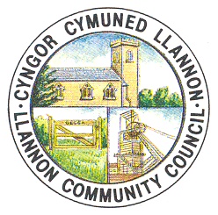
COMMUNITY DEVELOPMENT OFFICER
Llannon Community Council wishes to appoint an experienced Development Officer. The person appointed will plan, implement and monitor a range of community projects and events within the area, and also assist in ensuring the sustainability of Tumble Hall.
SWYDDOG DATBLYGU CYMUNEDOL
Mae Cyngor Cymuned Llannon yn chwilio am Swyddog Datblygu profiadol. Bydd y swydd yn ymwneud â gwaith cynllunio, gweithredu a monitro amrywiaeth o brosiectau a digwyddiadau cymunedol yr ardal, â chynorthwyo gyda’r gwaith o gynllunio cynaladwyedd Neuadd y Tymbl.
Hours of work: 30 – flexible including occasional evenings and weekends.
Salary: £26,999 pro rata
For an application pack and job description, please contact:
Mr David Davies, Cwmffrwd Farm, Llandeilo Road, Glanaman, SA18 2DZ. 07971 026493 daidoc@yahoo.co.uk.
Closing date: Friday, 13th December, 2019

