Local Development Plan

How to have your say!

Once you have clicked onto the Carmarthenshire Local Development Plan Link and registered. You should automatically be sent to this site page.

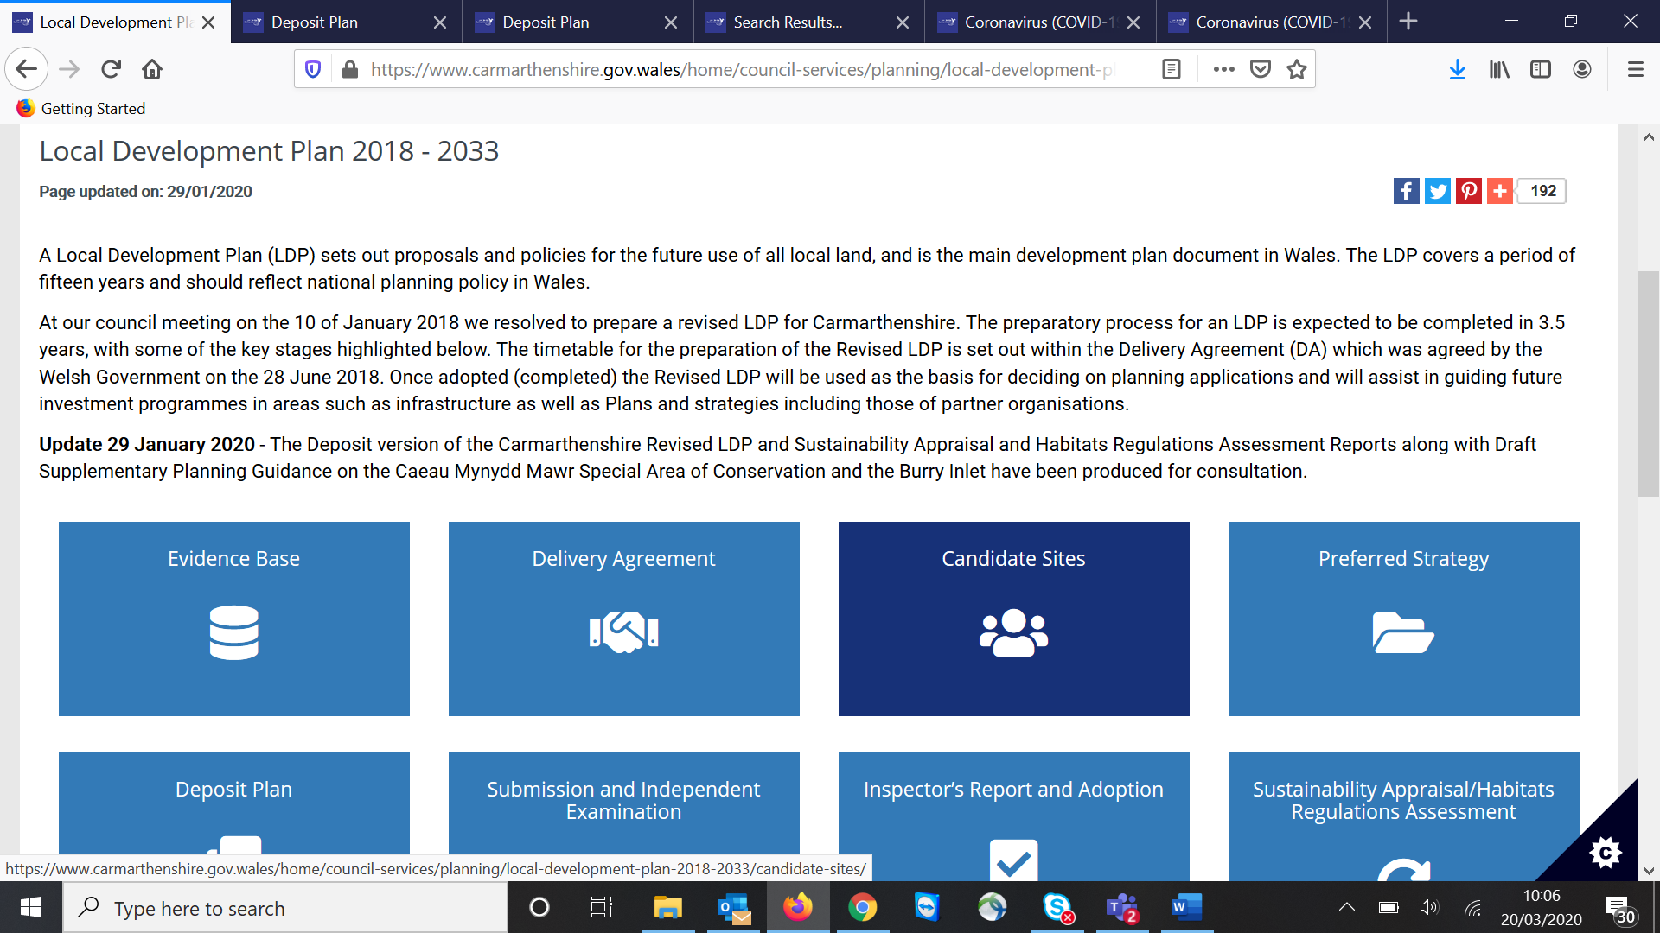

Click onto the **Deposit Plan**

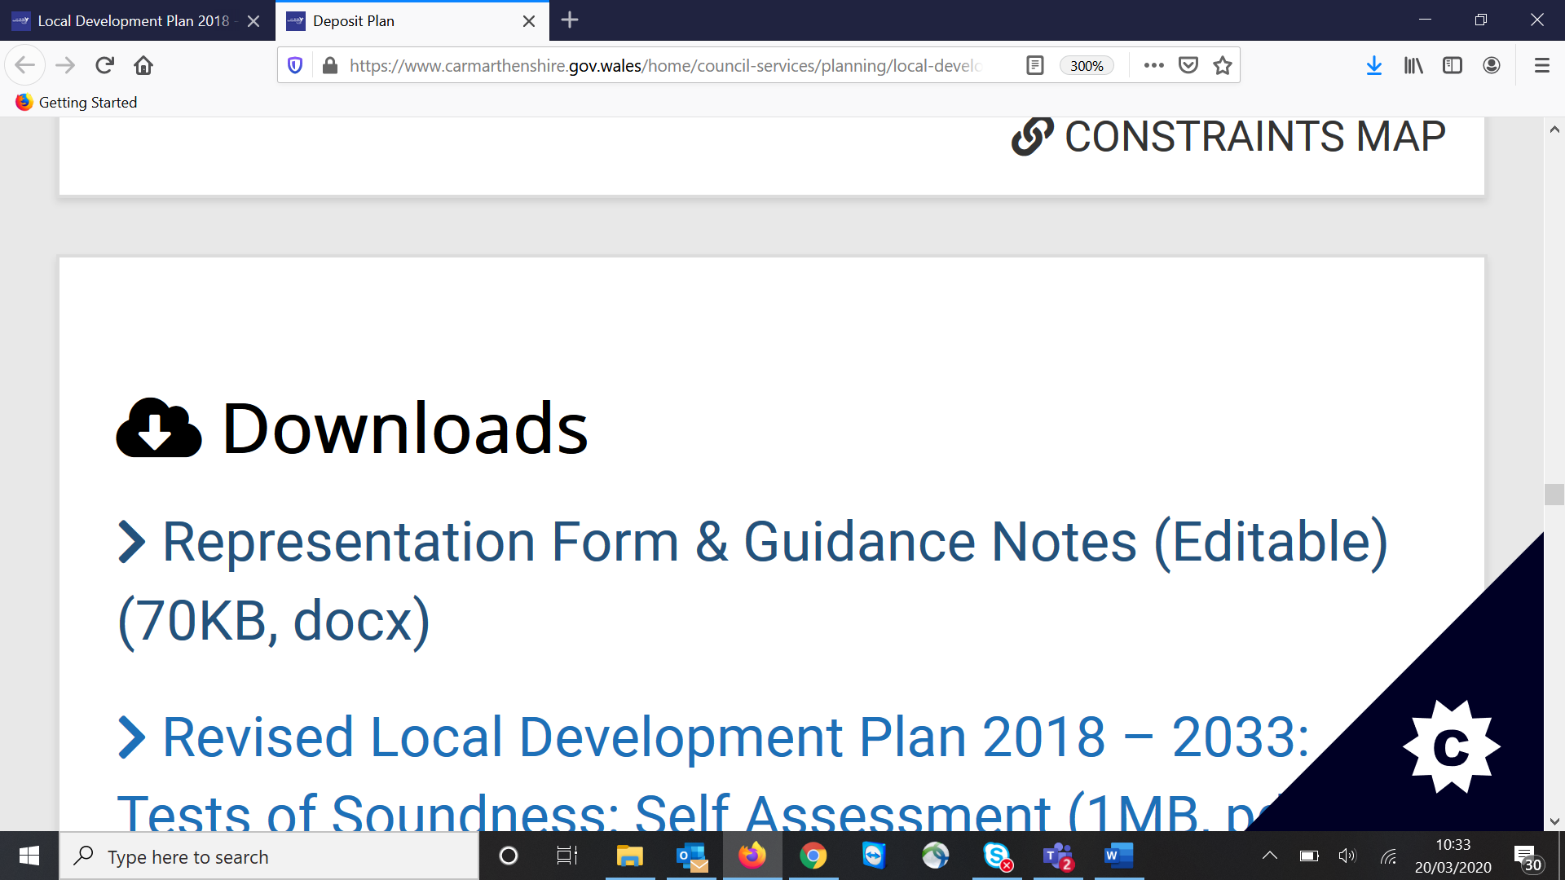

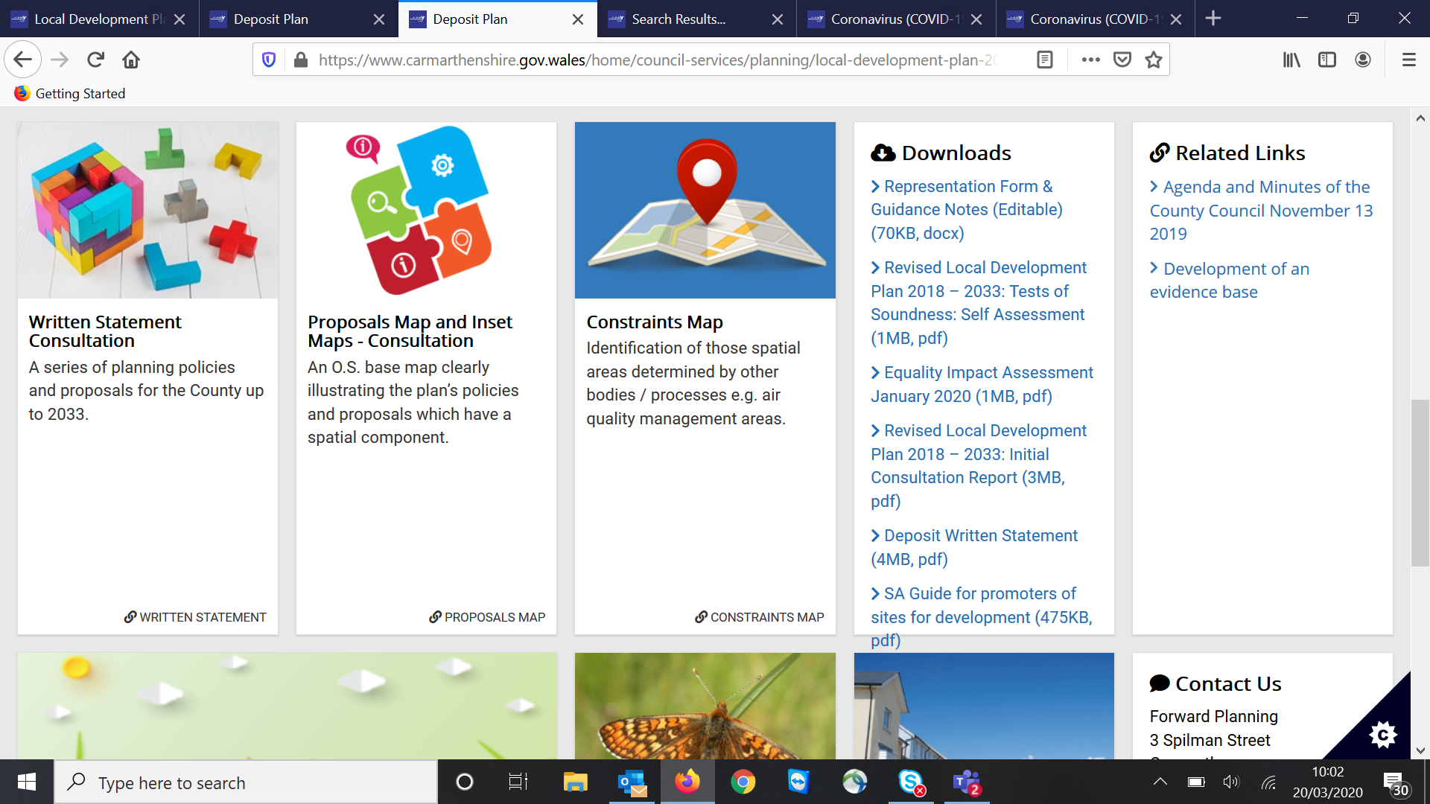

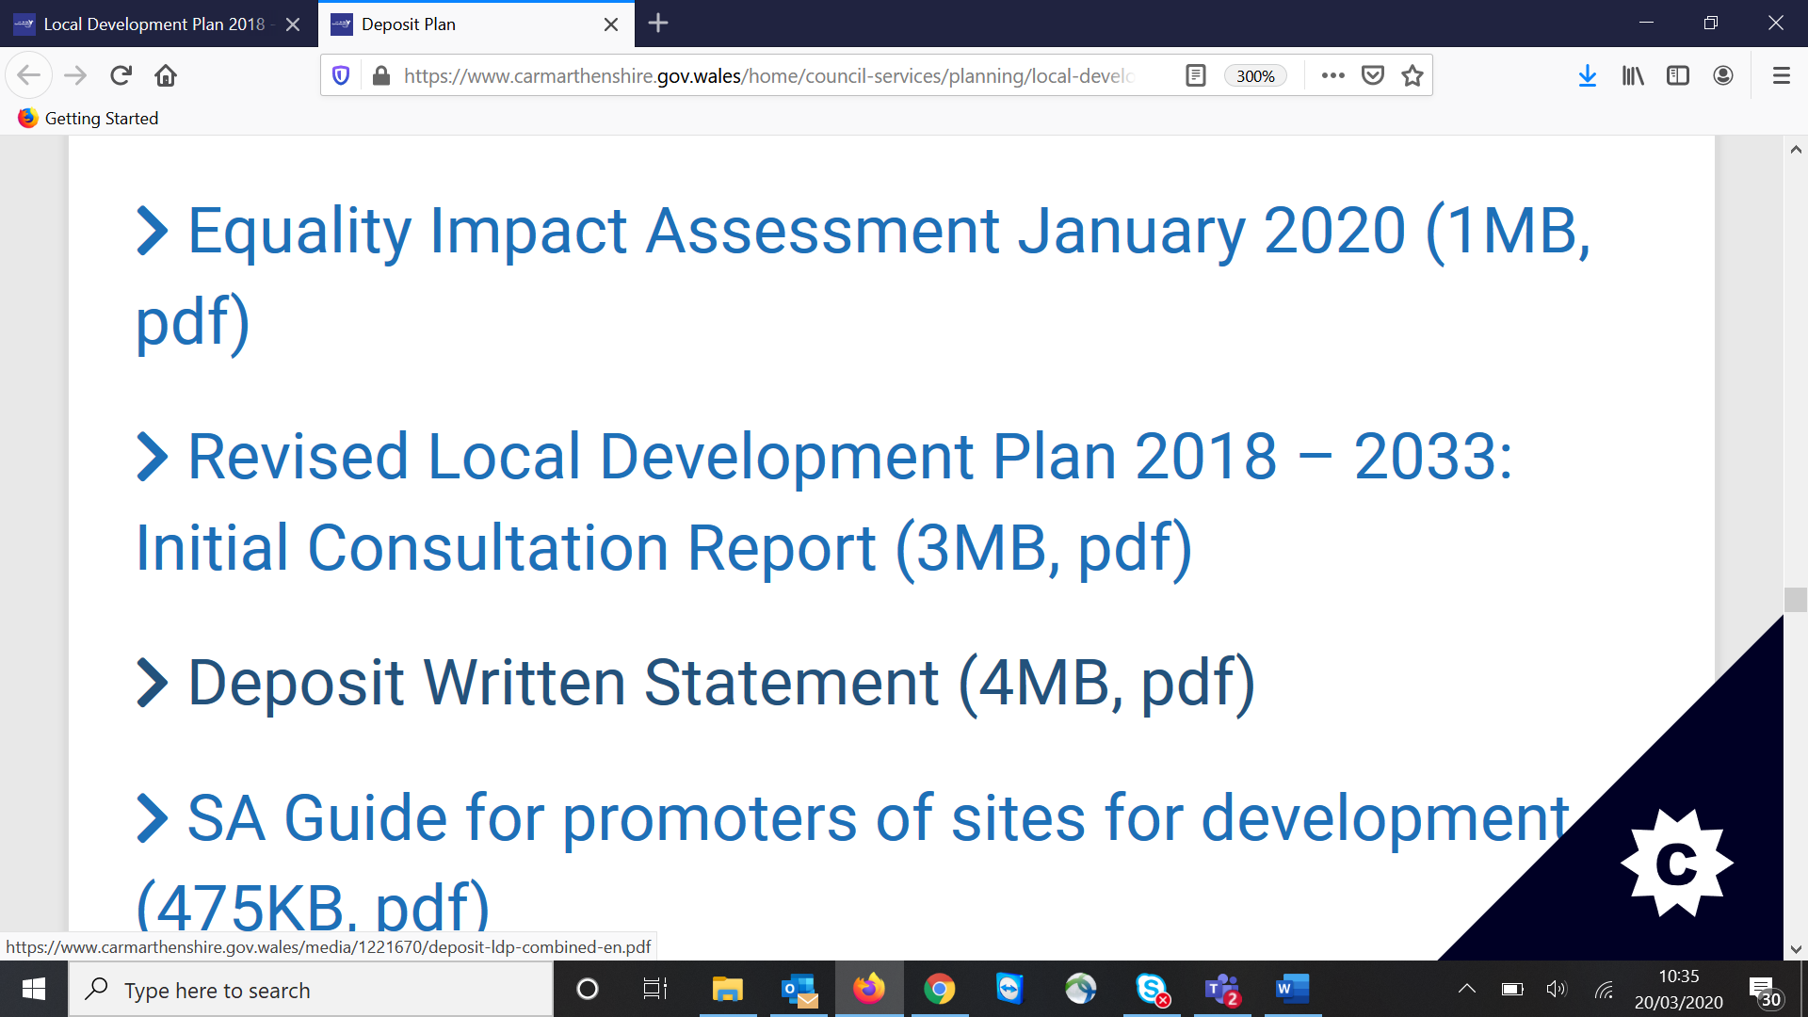

Click on ‘Deposit Written Statement’ and go to pp93 – 95. Cluster 3. Once you have also gone through supporting information – you can give feedback by downloading the ‘Representation Form’.