Schedule of Sites contained in Llannon Local Development Plan

Land at Heol Cae Pownd

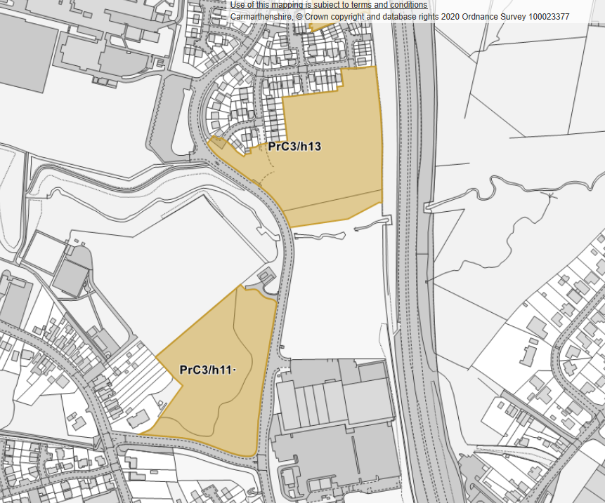

Land east of Carmarthenshire Road

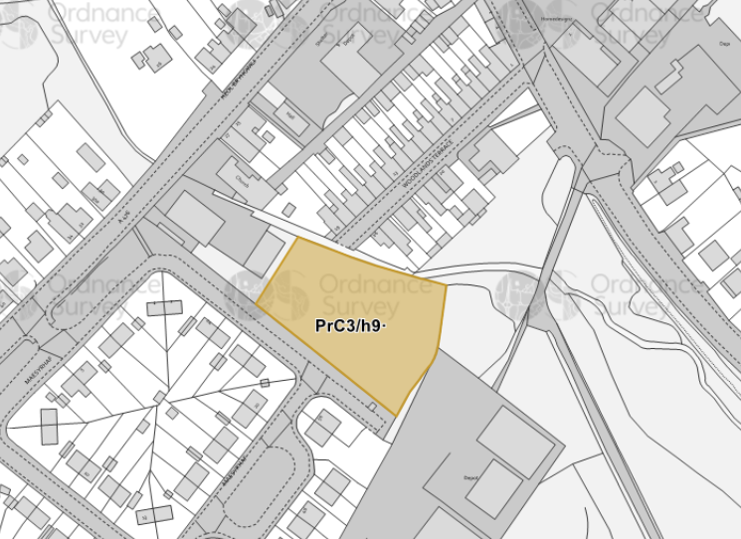

Land adjacent to Measyrhaf

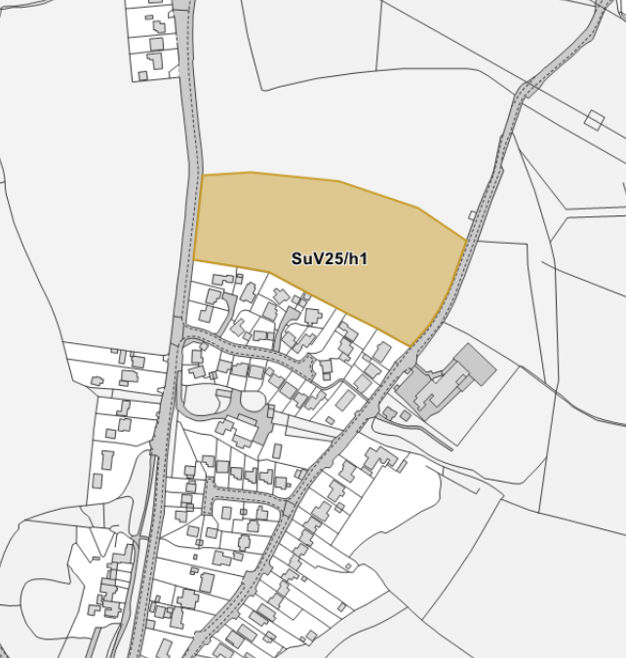

Land north of Clos Rebecca

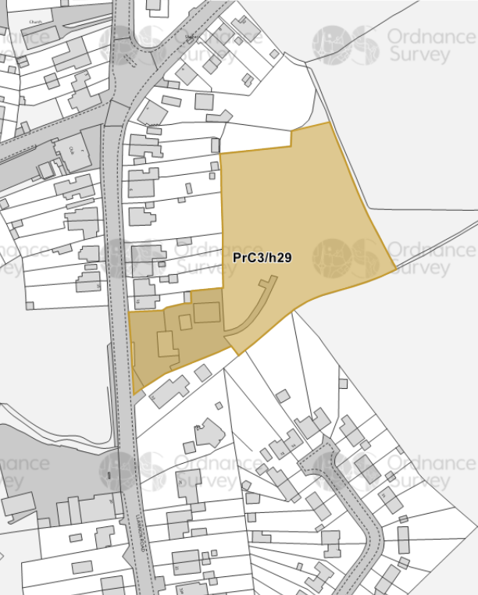

Central Garage

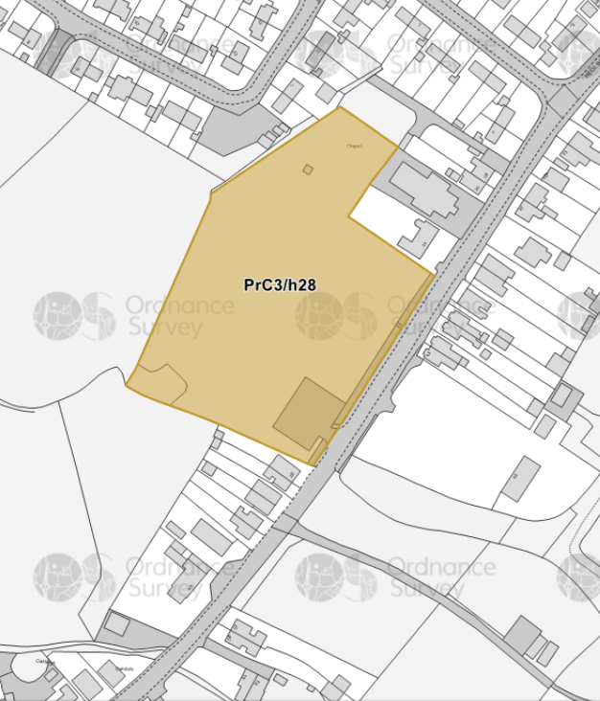

Land at Factory site between N 22 and 28 Bethesda Road

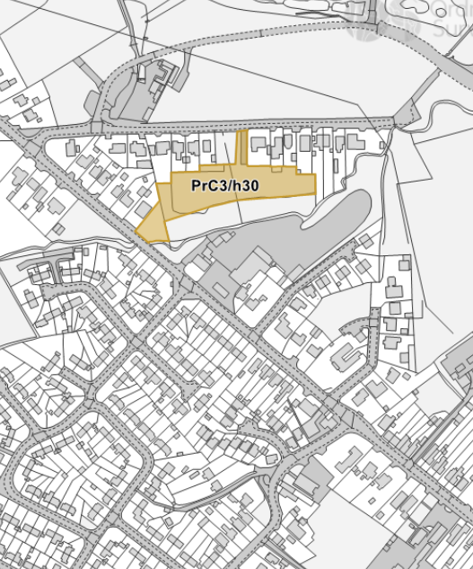

Land off Gwendraeth Road