Cyngor Cymuned Llannon Community Council
Clerc/ Clerk  Mr David Davies  Cwmffrwd Farm  Llandeilo Road  Glanamman  Carmarthenshire  SA18 2DZ  07971 026 493  david@ccllannon.org.uk | 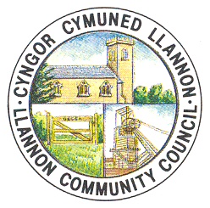 | SCC/Trysorydd RFO/Treasurer  Mr Chris Bowkett  Tumble Hall  Heol y Neuadd  Tumble  Carmarthenshire  SA14 6HR
web-site www.ccllannon.org.uk - wefan

7 Ebrill 2021 7th April 2021

Hysbysir bod cyfarfod arbenig o’r Notice is hereby given that a Special
Cyngor i’w gynnal nos Lun Ebrill 12 meeting of the Council is convened for Monday
am 7.30yn fel cyfarfod zoom ar lein. April 12th at 7.30pm as an online zoom meeting.

AGENDA AGENDA

1. Ymddiheuriadau am Absenoldeb. 1. Apologies for Absence.
2. Datgelu Buddianau. 2. Declaration of Interest.
3. I ystyried materion personel. 3. To consider personnel matters.
4. Ystyried noddi'r RFO ar gymhwyster CiLCA Un 4. To consider sponsoring the RFO on the One Voice
Llais Cymru. Wales CiLCA qualification.

D R Davies D R Davies
Clerc Clerk

