Cyngor Cymuned Llannon Community Council
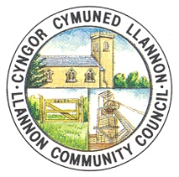

AT: HOLL AELODAU CYNGOR CYMUNED LLANNON
DYDDIAD: 10/12/2021

Annwyl Gynghorydd,
Drwy hyn, cewch eich galw i fynychu Cyfarfod Cyffredinol Eithriadol o Gyngor Cymuned Llannon, a gynhelir drwy Zoom ddydd Mercher, 15 Rhagfyr 2021 am 6.30pm.

AGENDA

1. Ymddiheuriadau a rhesymau dros absenoldeb.
2. Datgelu buddiannau.
3. Trafod y Prosiect Cross Hands Deg Tref.

TO: ALL MEMBERS OF LLANNON COMMUNITY COUNCIL
DATE: 10/12/2021

Dear Councillor,

You are hereby summoned to attend an Extraordinary General Meting of Llannon Community Council, to be held via Zoom on Wednesday, 15th December 2021 at 6.30pm.

AGENDA

1. Apologies and reasons for absence.
2. Declarations of interest.
3. To discuss the Cross Hands Ten Towns Project.

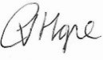
C Hope (Clerc/Clerk)

