Cyngor Cymuned Llannon Community Council
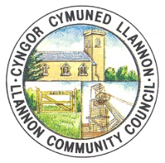
TO: ALL MEMBERS OF LLANNON COMMUNITY COUNCIL
DATE: 19/11/2021

Dear Councillor,

You are hereby summoned to attend a full council meeting of Llannon Community Council, to be held via Zoom on Wednesday, 24th November 2021 at 6.30pm.

AGENDA

1. Apologies and reasons for absence.
2. Declarations of interest.
3.. To receive an update on the RIOT Urban Sports Park.
4. To receive an update on the Remembrance Sunday event.
5. To discuss and agree an action plan for the distribution of Christmas Food Hampers.
6. To receive quotations for the replacement of fire doors in Tumble Hall.
7. To discuss the location of a defibrillator as per the WAST/Save a Life Cymru grant.
8.. To review a request for financial assistance from Fairtrade.
9. To discuss the Queen’s Platinum Jubilee arrangements.
10. To discuss the possibility of Llannon Community Council Local Hero Awards.
11. To receive an update regarding the internal auditor.
12. To discuss the appointment of a solicitor.
13. To agree Terms of Reference for the following committees:
a) Finance Committee
b) Personnel Committee
c) Environment Committee
d) Hall Management Committee
14. To update the composition of the following committees in accordance with their new Terms of Reference:
a) Finance Committee
b) Personnel Committee
c) Environment Committee
d) Hall Management Committee
15. To agree an Employees Expenses Policy & Procedure.
16. To discuss personnel matters.

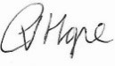
C Hope (Clerk)

In accordance with the Public Bodies (Admission to Meetings) Act 1960, s1(2) and the Local Government Act 1972, s,100(2), members of the public and press will be asked to leave the meeting after Item 17.

