Cyngor Cymuned Llannon Community Council
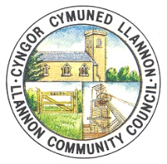
TO: ALL MEMBERS OF LLANNON COMMUNITY COUNCIL
DATE: 11/02/2022

Dear Councillor,

You are hereby summoned to attend a full council meeting of Llannon Community Council, to be held via Zoom on Wednesday, 16th February 2022 at 6.30pm.

AGENDA

1. Apologies and reasons for absence.
2. Declarations of interest.
3. To consider policing matters.
4. Confirmation of minutes of the Council meeting held on 26th January 2022.
5. To receive a verbal report from the Clerk.
6. To discuss the following planning application:
PL/03377 – Proposed change of use existing (part) of first floor storage area into two- bedroom flat – Cefneithin RFC, 96 Carmarthen Road, Carmarthenshire, SA14 6SU.
7. To discuss the recent site visit of Cross Hands Park concerning the proposed bridlepath.
8. To discuss the Tumble Active Travel Draft Masterplan.
9. To discuss the following requests for financial assistance:
a) Foothold Cymru.
b) Carmarthenshire County Council Chair’s Appeal 2021/2022
10. To discuss correspondence received from Tumble AFC regarding potential surrender of their sub-lease.
11. To receive Councillor’s reports.
12. To receive County Councillor’s reports.
13. To discuss the return of “Country & Western” nights at Tumble Hall.
14. To receive an update regarding the cemeteries.
15. To discuss personnel matters.

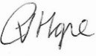
C Hope (Clerk)

In accordance with the Public Bodies (Admission to Meetings) Act 1960, s1(2) and the Local Government Act 1972, s,100(2), members of the public and press will be asked to leave the meeting after Item 13.

