Cyngor Cymuned Llannon Community Council
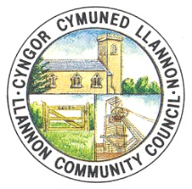
AT: HOLL AELODAU PWYLLGOR CYLLID CYNGOR CYMUNED LLANNON
TO: ALL MEMBERS OF LLANNON COMMUNITY COUNCIL HALL MANAGEMENT COMMITTEE
DYDDIAD/DATE: 16/02/2022
AMSER/TIME: 17:30

Annwyl Gynghorydd

Drwy hyn, cewch eich galw i fynychu cyfarfod cyngor llawn o Gyngor Cymuned Llannon, a gynhelir drwy Zoom ddydd Llun, 21 Chwefror 2022 am 5.30pm.

1. Ymddiheuriadau a rhesymau dros absenoldeb.
2. Datganiadau o fuddiant.
3. Trafod syniadau ar gyfer defnyddio'r Neuadd ar gyfer y flwyddyn ganlynol ac ystyriaethau cyllidebol.

Dear Councillor,

You are hereby summoned to attend a full council meeting of Llannon Community Council, to be held via Zoom on Monday, 21st February 2022 at 5.30pm.

AGENDA

1. Apologies and reasons for absence.
2. Declarations of interest.
3. To discuss ideas for the use of the Hall for the following year and budget considerations.

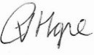
C Hope (Clerk)

