From: Cllr. Dot Jones
Sent: 09 August 2022 18:28
To: Clare Hope
Subject: county Council report

Hi All,

Apologies this report is late.

I was pleased to see the patching repair work take place shortly after the election along the A476, following a meeting I had with the highways officer pre election.

Again the double yellow lines on Heol Bryngwili by the car garage which was a joint project with Cllr Emlyn Dole and Myself and was delayed
due to other issue’s /covid that were on the same traffic notice , I have requested the enforcement officer includes the area as part of their patrol to ensure the
yellow lines are now adhered to.

I have also requested a post 6pm enforcement patrol by Cymru Balti , Tumble following complaints the jct is dangerous coming out of Pen Parc.

I received a message from a resident who questioned why Pen Parc was now called Park place, unfortunately the wrong road sign had been placed a new Road sign has been ordered and will be installed asap.

Residents in Tir Becca/ Tyisha requested a street rubbish bin, that has now been placed on Tyisha Road.

I have attached an image from a resident who has carried out the work on the fence by the lane of Pen Park as they were protecting the privacy of the park users and their own privacy.

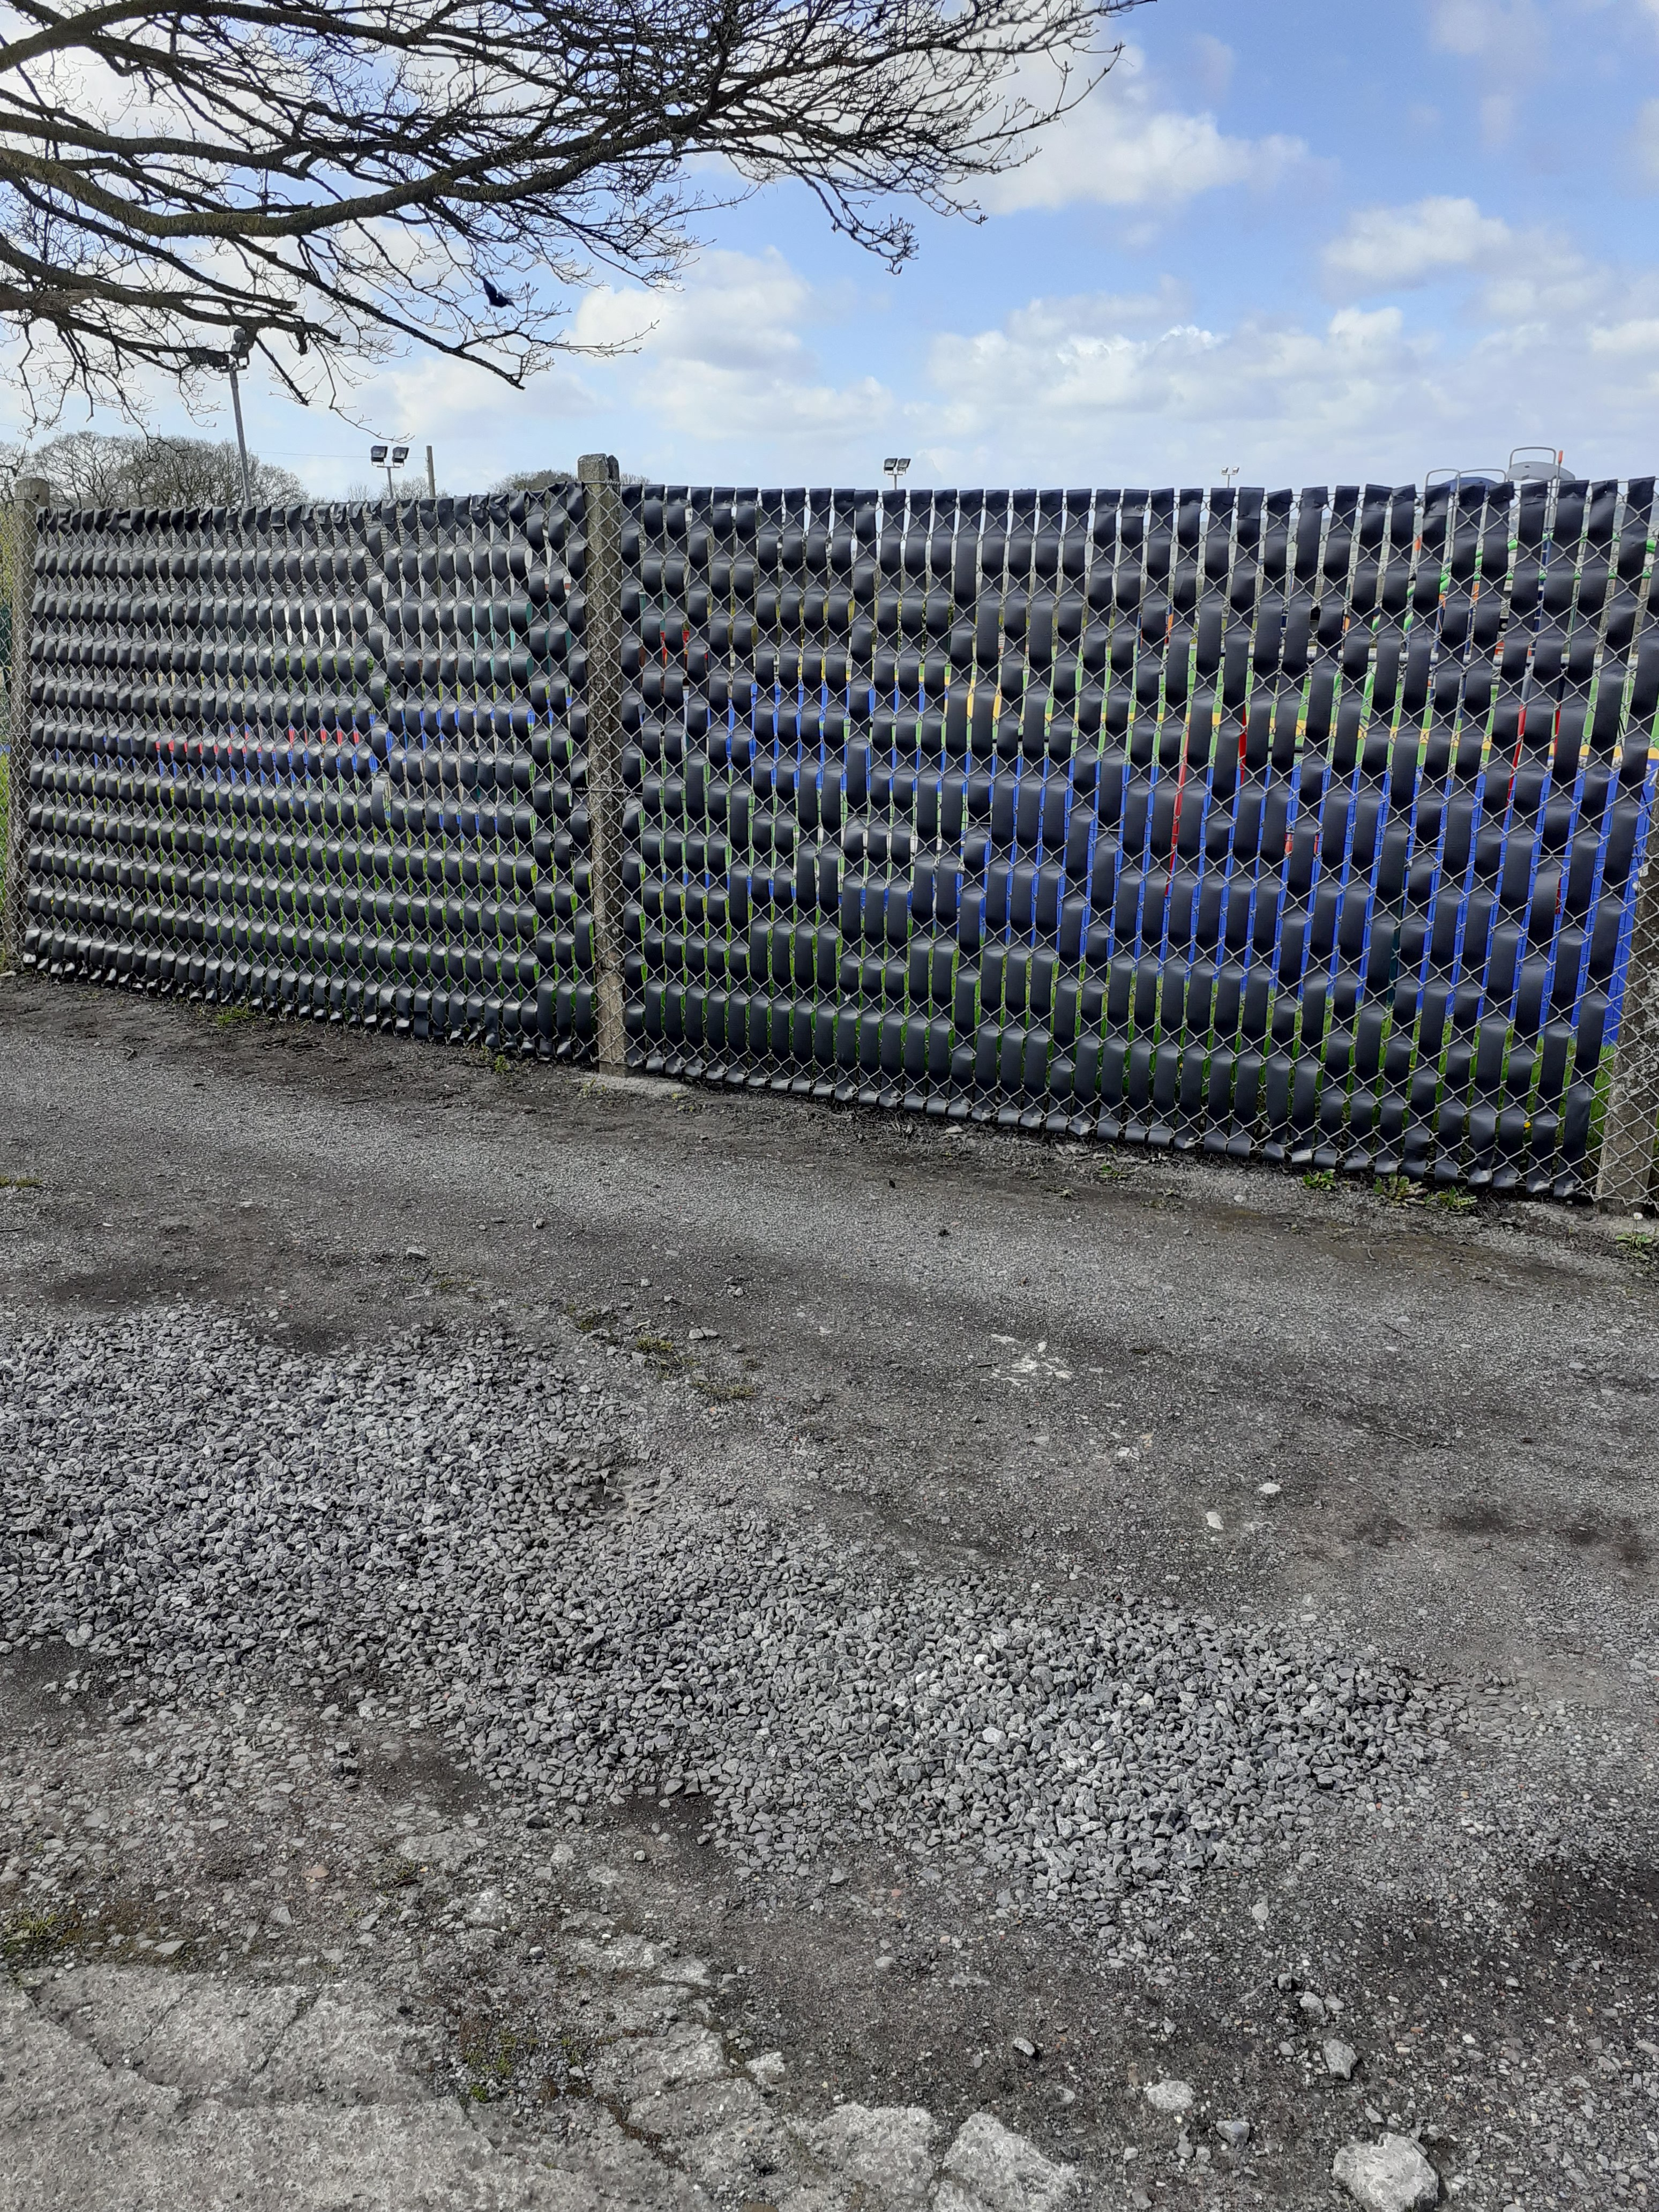
A very successful Skip session was held in Tir Bacca with the housing department following several issues that were highlighted during an estate walk.

I received a complaint about a dangerous tree in Maes Yr Haf, I’m pleased to report work has now started to make it safe.

There have been multiple complaints from residents regarding County Council owned land needing to be cut and maintained which I am dealing with.

I have been working with residents who have been impacted by the anti-social behaviour in Lidl’s carpark, I have correspondence with the local police and enforcement officers to try and find a resolve on this issue. Lidl themselves are weighing up a number of options to help the local residents.

I was contacted regarding the grass behind high street, I’m pleased that County acted swiftly and the residents were pleased that the route can now be walked again.

I have dealt with multiple cases of fly tipping some reported to me some I have seen myself. It will be interesting to see what impact if any the local amenity centres returning to pre pandemic ways of working will have on the amount of cases.

I spotted a broken bollard by the bus shelter in Crosshands with a dangerous hole left in the pavement, as County could not obtain a colour match to the remaining bollard 2 new bollards will be installed.

I am dealing with a number of housing issues, unfortunately covid has impacted housing repairs and there is a large backlog.

As stated in another report I was voted in as the new Chair of the !0 towns Project. Thank you to Cllr Dole for all the hard work already carried out with the 10 towns project.

On a county level, I was part of the panel for the new head of service post , I have attended multiple training sessions , Crwg , licensing and shadow cabinet meetings, meeting with director of education, and hopefully scrutiny committees which up until now have not met will start in September. The school transport advisory panel which was formed in the previous term was reported to have concluded their work in a cabinet meeting early July, the following week I asked the Cabinet for a copy of the report , the cabinet member answered my question stating the group never met but has invited myself to meet with him to discuss School transport going forward. This situation is still a great concern for our residents and with the cost-of-living crisis will families be able to afford the bus fare for their children.

I attended the last Police meeting and will be feeding back that the new format doesn’t feel right for the Llannon Ward/ Gwendreath Valley as a lot of time is spent talking about Ammanford.
During the meeting I did raise some anti-social behaviour and forwarded cctv footage on to the police following my husband and myself going to replace a storm drain cover on a Friday night before there was a road traffic accident.

I had a joint surgery with Dame Nia Griffith MP and spoke with a few residents who attended the meeting some county issues were raised along with Community council concerns.

I have been advised by Go Safe that at the moment Community Speed watch sessions are not allowed to take place whilst some issue is being looked at.

I have a number of personal cases that I am currently dealing with.

Kind regards
Dot
07597363524

