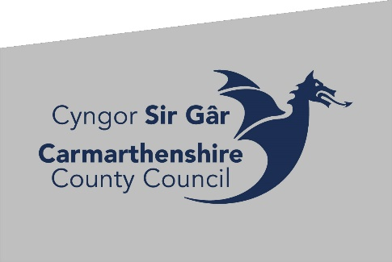

Notice of a Community Review
Town/Community Councils in the Carmarthenshire County Council Area
Local Government (Democracy) (Wales) Act 2013 (the Act)
Carmarthenshire County Council is undertaking a Community Review of the Town and Community Councils within the area to enable the Council to consider if any changes are needed to the current Town/Community arrangements.
The council is conducting the first stage of the Review process and is inviting residents and interested organisations to submit their views on existing arrangements, together with any proposals for change, from Monday 13, March, 2023 until Monday 24, April, 2023.
The council has published its Terms of Reference for the Review and a copy can be viewed and downloaded from the Council’s website or obtained by contacting the Electoral Services team as shown below.
Should you wish to submit a written representation regarding this review please email AmEdwards@carmarthenshire.gov.uk or post it to :
Electoral Services
Block 4
Parc Myrddin
Richmond Terrace
Carmarthen
SA31 1HQ
The dates for submissions for the first stage are from 13 March to 24 April 2023.
Dated: 10 March 2023

