Community Involvement
As with any development or proposal it is essential to get the local community engaged. Information must be disseminated widely so lots of residents are aware of proposals and the reasoning behind the decisions.
The toolkit produced by Welsh Government has several posters that can be downloaded, Llannon Community Council logo can be added on and importantly they are available in Welsh and English.
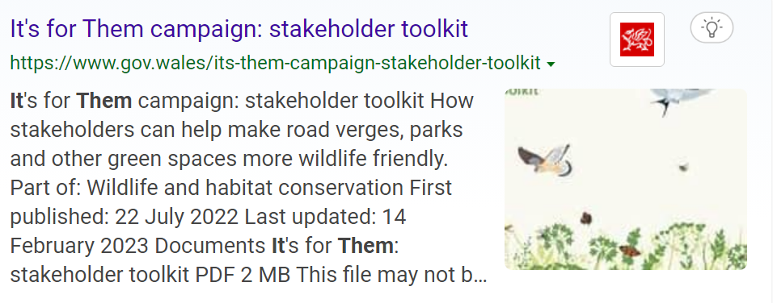
Stakeholder Toolkit document attached and Welsh pamphlet document. You Tube video animation to support the campaign is available
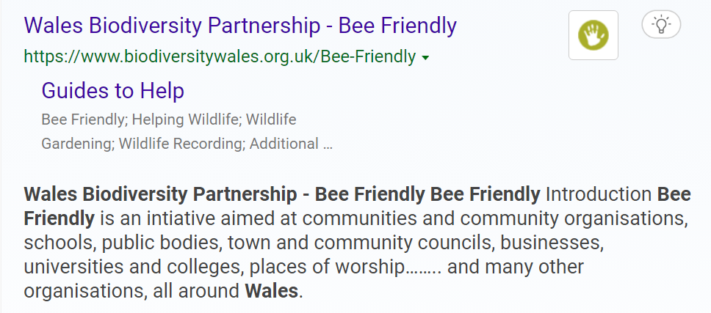
Bilingual resource
Leaflets that are produced by LlCC will have many different target audiences.
- Displayed on Noticeboards,
- Sent to schools to encourage participation in campaign
- Leaflets to put through resident’s doors in project areas
- Cards or leaflets to give to members of the public when Grounds Maintenance Staff are working
- Put on Social media and website

Before a Grant Application is submitted for Tyisha Park is submitted a full consultation meeting and questionnaires will be needed for residents to be fully involved and participating in decisions and development.
Whether there is a call for community garden, sensory gardens etc.

