Cyngor Cymuned Llannon Community Council
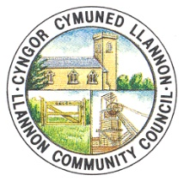

AT: HOLL AELODAU CYNGOR CYMUNED LLANNON
TO: ALL MEMBERS OF LLANNON COMMUNITY COUNCIL
DYDDIAD/DATE: 07/03/2026

Annwyl Gynghorydd/Dear Councillor,

Yr ydych yn cael eich galw felly i fynychu Cyfarfod Cyffredinol Brys Cyngor Cymuned Llannon, i'w gynnal trwy MS Teams ar 09/03/2026 am 17:30.

You are hereby summoned to attend an Emergency General Meeting of Llannon Community Council, to be held via MS Teams on 09/03/2026 at 17:30.

AGENDA

- Ymddiheuriadau a rhesymau dros absenoldeb/Apologies and reasons for absence.

- Datgelu buddiannau/Declarations of interest.

- I fabwysiadu Polisi Iechyd a Diogelwch newydd ar gyfer Neuadd Y Tymbl/To adopt a new Health & Safety Policy for Tumble Hall.

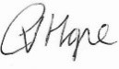
Mrs Clare Hope (Prif Swyddog/Chief Officer)

Dolen i ymuno â'r cyfarfod/Link to join the meeting:
EGM | Meeting-Join | Microsoft Teams

