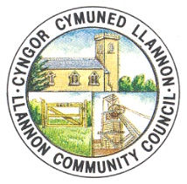
LLANNON COMMUNITY COUNCIL
FULL COUNCIL MEETING DATES
2026-27

Wednesday, 20th May 2026, 6pm (Annual Meeting)
Wednesday, 17th June 2026, 6.30pm
Wednesday, 15th July 2026, 6.30pm
Wednesday, 30th September 2026, 6.30pm
Wednesday, 21st October 2026, 6.30pm
Wednesday, 25th November 2026, 6.30pm
Wednesday, 27th January 2027, 6.30pm
Wednesday, 24th February 2027, 6.30pm
Wednesday, 17th March 2027, 6.30pm
Wednesday, 19th May 2027, 6pm (Annual Meeting)

All meetings be held remotely via MS Teams, unless otherwise specified on the agenda. If a meeting is unable to go ahead on any of the above dates, Members will be notified by e-mail and a notification will be published on the agenda and minutes section of the Council’s website.
Please note that extraordinary meetings may be called whenever there are items requiring the Council’s attention in between the above dates.
The Finance Committee will endeavour to meet on the second Monday of each month. All other committees will meet as and when necessary.

Approved: 20th May 2026

