Cyngor Cymuned Llannon Community Council
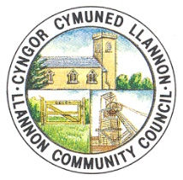

AT: HOLL AELODAU PWYLLGOR PERSONEL CYNGOR CYMUNED LLANNON
TO: ALL MEMBERS OF THE PERSONNEL COMMITTEE OF LLANNON COMMUNITY COUNCIL
DYDDIAD/DATE: 03/06/2026

Annwyl Gynghorydd /Dear Councillor,

Yr ydych yn cael eich galw i fynychu Cyfarfod Pwyllgor Personél Cyngor Cymuned Llannon, a gynhelir yn Neuadd Tumble am 10:00 ar Ddydd Llun, 8 Mehefin 2026.

You are hereby summoned to attend a Personnel Committee Meeting of Llannon Community Council, to be held at Tumble Hall at 10:00 on Monday, 8th June 2026.

AGENDA

- I benodi Cadeirydd y Pwyllgor/To appoint the Chair of the Committee.
- Ymddiheuriadau a rhesymau dros absenoldeb / Apologies and reasons for absence.
- Datgelu buddiannau / Declarations of interest.
- I drafod cwyn ffurfiol a dderbyniwyd ynghylch aelod o staff/To discuss a formal complaint received regarding a staff member.

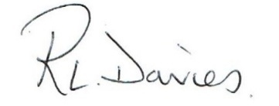

Ruth Lloyd-Davies (Cadeirydd/Chair)

In accordance with the Public Bodies (Admission to Meetings) Act 1960, s1(2) and the Local Government Act 1972, s,100(2), members of the public and press are not able to attend the meeting due to the nature of the information to be discussed.

