Cyngor Cymuned Llannon Community Council
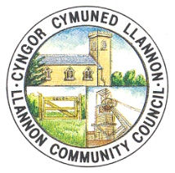

Minutes of the Finance Committee of Llannon Community Council
Monday 10th August 2026 at 5.00pm
Held via Teams
Meeting commenced at 5.00pm
The Chair, Cllr. J. Owen presided over the meeting.

Minute No. 11 – Members Present.

Cllr. R. Lloyd Davies (RD)
Cllr. J. Owen (JO)
Cllr. J. Burree (JB)
Cllr. J. Anderson (JA)

Also Present:

Miss Ff. Davies – Deputy Chief Officer & RFO (FD)

Minute No. 12 – Apologies and reasons for absence.

There were no apologies for absence.

Minute No. 13 – Declarations of Interests.

There were no new declarations of interests.

Minute No. 14 – To review the Council’s Cashbooks and Payments for June 2026.

The RFO previously circulated the following Cashbooks and Payments to all members of the Finance Committee via email:
- Soldo Account Cashbook and Payments June 2026.
- Council Account Cashbook and Payments June 2026.
- Hall Account Cashbook and Payments June 2026.
- Precept Account Cashbook June 2026.
- Reserves Account Cashbook June 2026.
- Y Cwtsh Cashbook June 2026.
- Cinio a Chlonc Cashbook June 2026.

The Chair asked the members present if there were any questions with regards to the above Cashbooks and Payments. The members present discussed all the Cashbooks and Payments presented to them.

JB proposed that the Finance Committee ratify the above Cashbooks and Payments as previously circulated via email from the RFO. RD seconded the proposal. All members present in favour.

Resolved that the Soldo Account Cashbook and Payments for June 2026, Council Account Cashbook and Payments for June 2026, Hall Account Cashbook and Payments for June 2026, Precept Account Cashbook for June 2026, Reserve Account Cashbook for June 2026, Y Cwtsh Cashbook for June 2026, and Cinio a Chlonc Cashbook for June 2026 are ratified.

Minute No. 15 – To receive the Bank Reconciliation for June 2026.

The RFO previously circulated the Bank Reconciliation for June 2026 to all members of the Finance Committee via email.

RD proposed that the Finance Committee accept the Bank Reconciliation for June 2026 as previously circulated via email from the RFO. JB seconded the proposal. All members present in favour.

Resolved that the Bank Reconciliation for June 2026 has been received and verified by all members present.

5.05pm Cllr. J. Anderson joined the meeting.

Minute No. 16 – To receive the Budget Monitoring Spreadsheet up to 30/06/2026.

The RFO previously circulated the Budget Monitoring Spreadsheet to all members of the Finance Committee via email.

RD proposed that the Finance Committee accept the Budgeting Monitoring Spreadsheet up to 30/06/2026 as previously circulated via email from the RFO. JB seconded the proposal. All members present in favour.

Resolved that the Budget Monitoring Spreadsheet up to 30/06/2026 has been received and verified by all members present.

Minute No. 17 – To receive the Quarter 1 Finance Report.

The RFO previously circulated the Quarter 1 Finance Report to all members of the Finance Committee via email.

The RFO reported the following Bank Balances as of 30th June 2026 to the Finance Committee:

- Council Account £ 1854.10
- Hall Account £ 907.54
- Precept Account £ 299.97
- Reserves Account £ 37567.74

There were no questions raised from the members present.

JA proposed that the Finance Committee accept the Quarter 1 Finance Report as previously circulated via email from the RFO. JB seconded the proposal. All members present in favour.

Resolved that the Quarter 1 Finance Report has been received and verified by all members present.

Minute No. 18 – To agree the date of the next Finance Committee meeting.

It was agreed by all members present that the next meeting of the Finance Committee will be held on Tuesday 22nd September at 5.00pm.

The Chair closed the meeting at 5.16pm

Signed ............................................................. Date ....................................

(Chair)

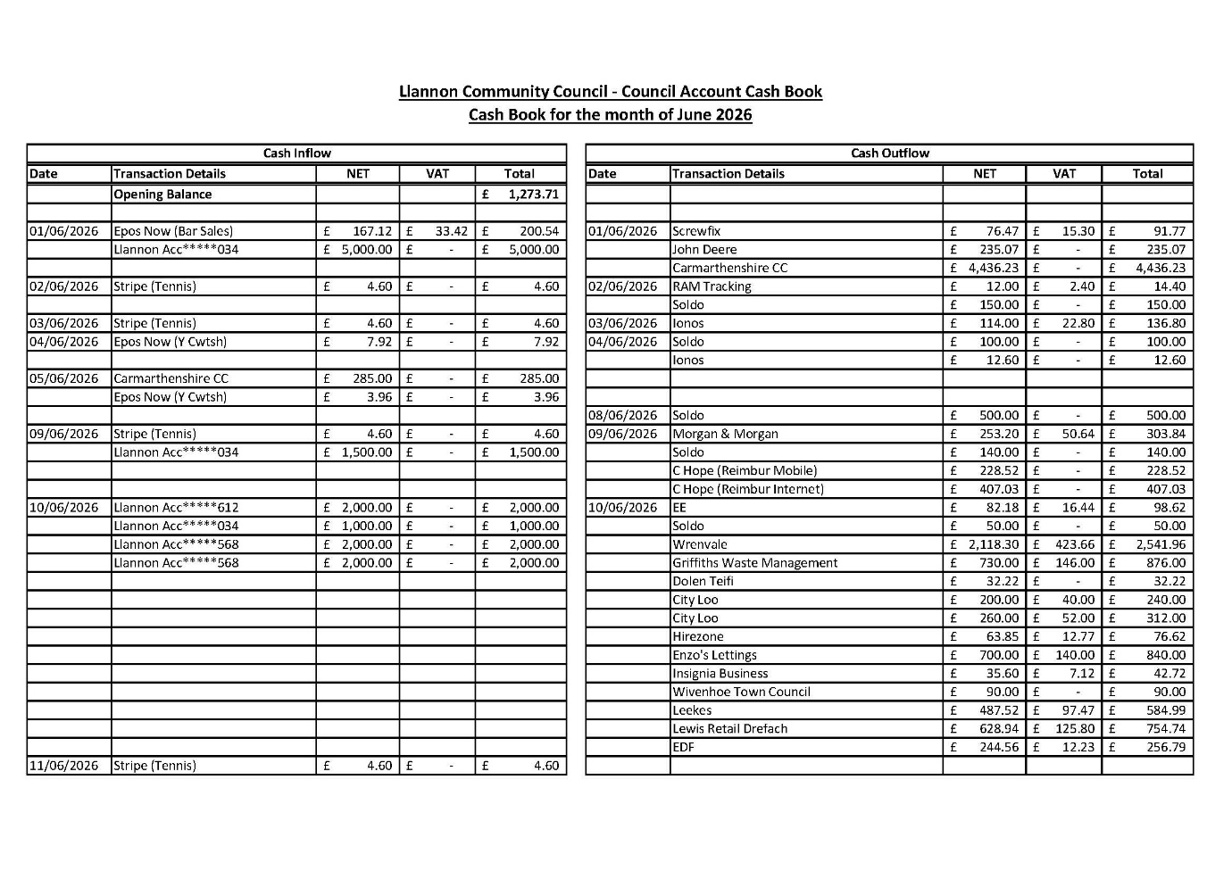
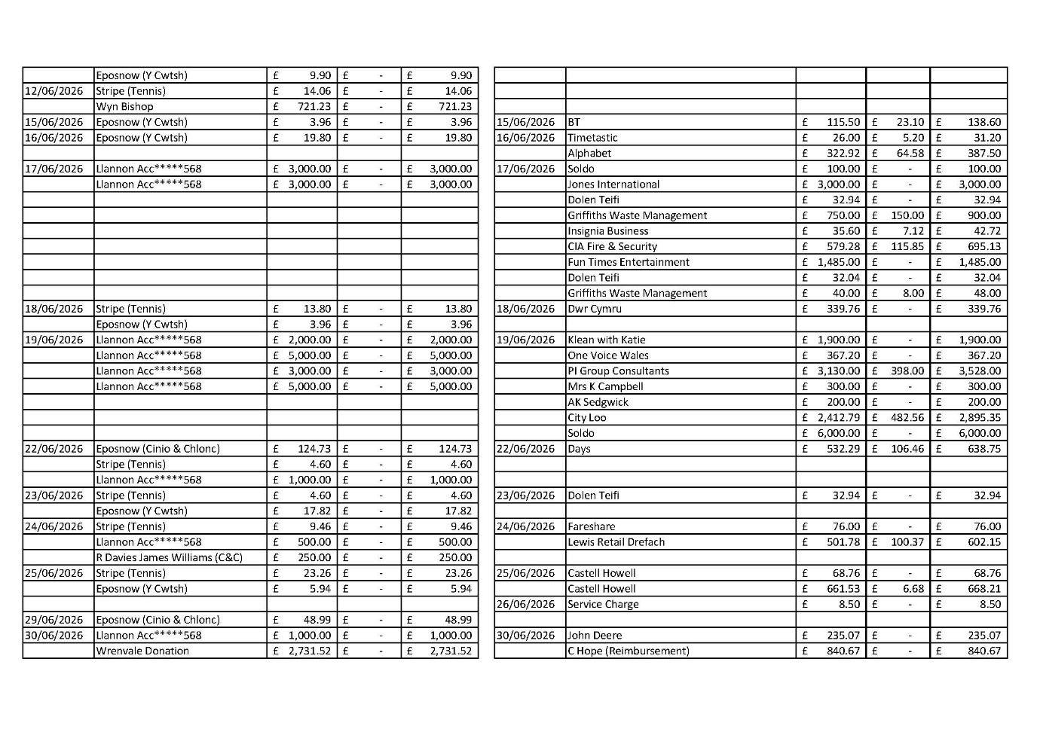
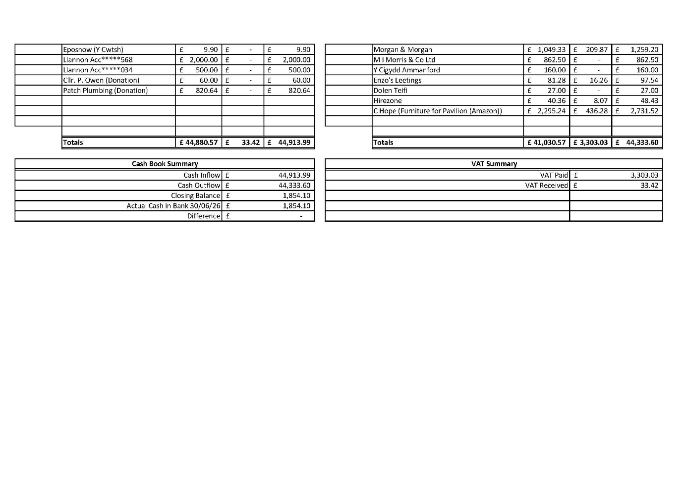
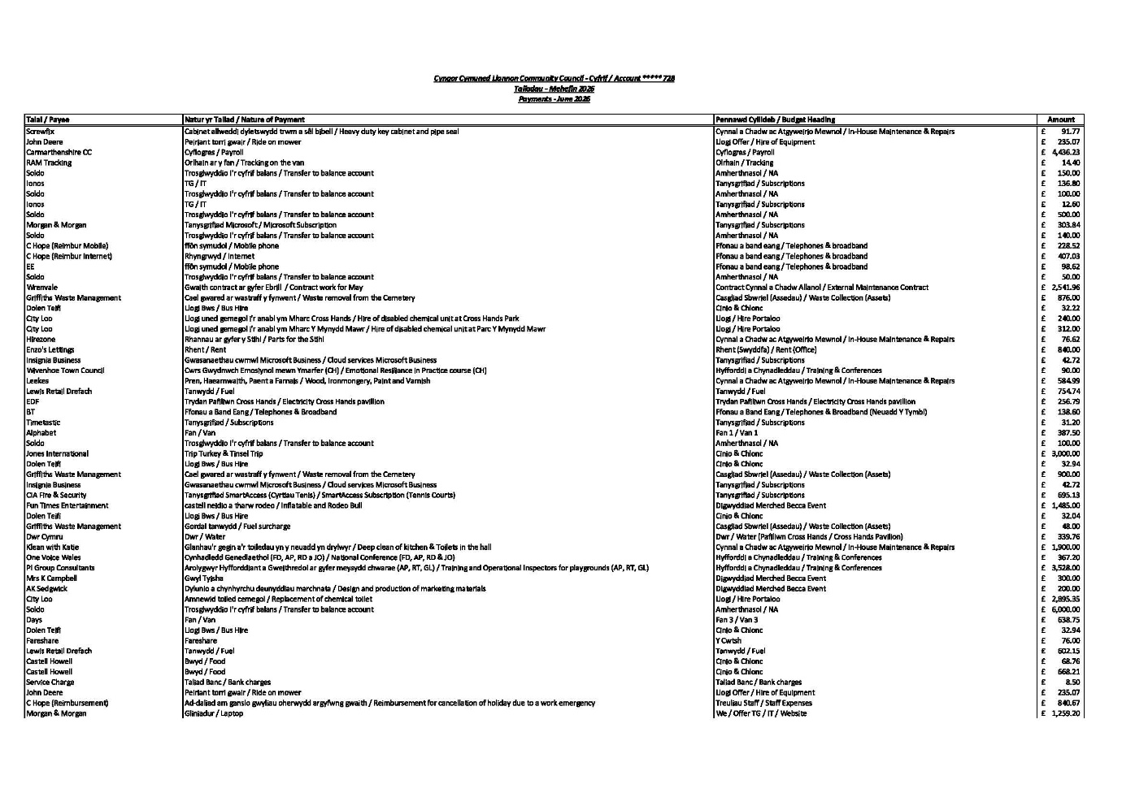
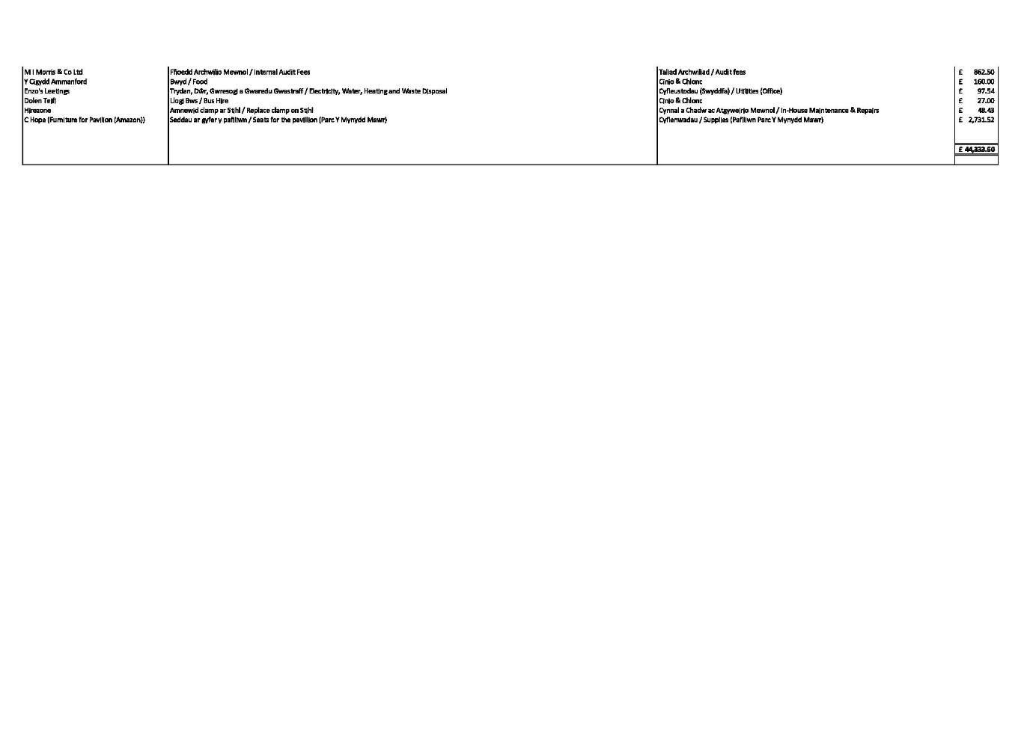
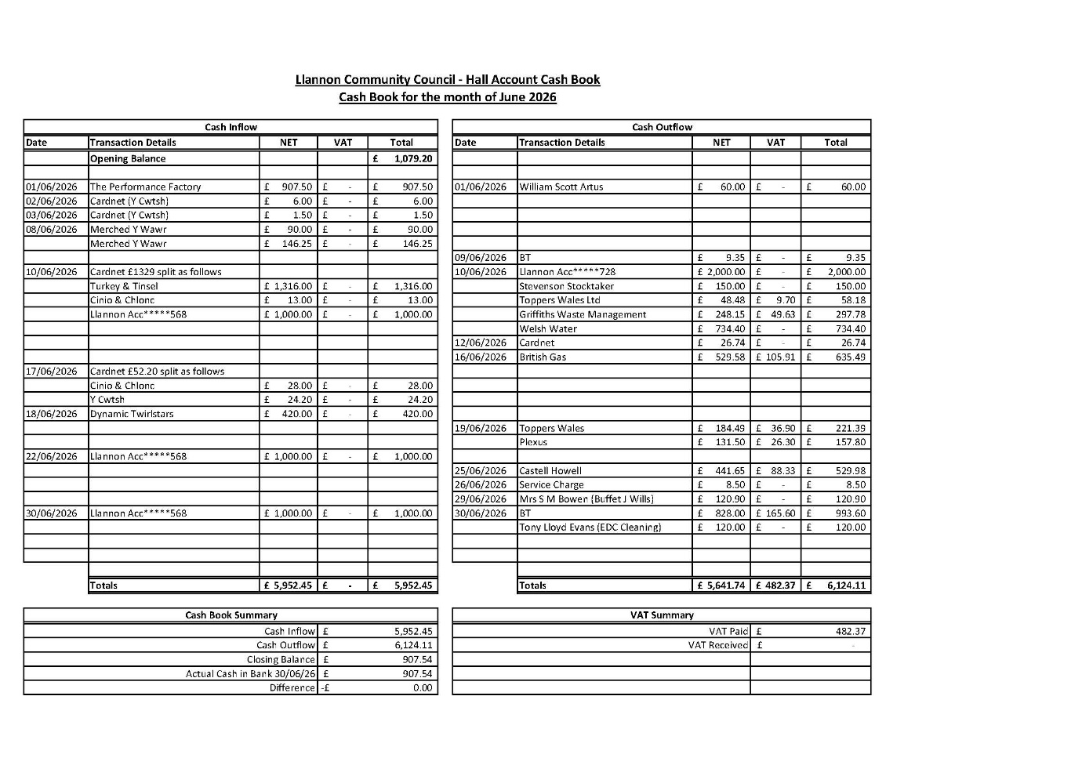
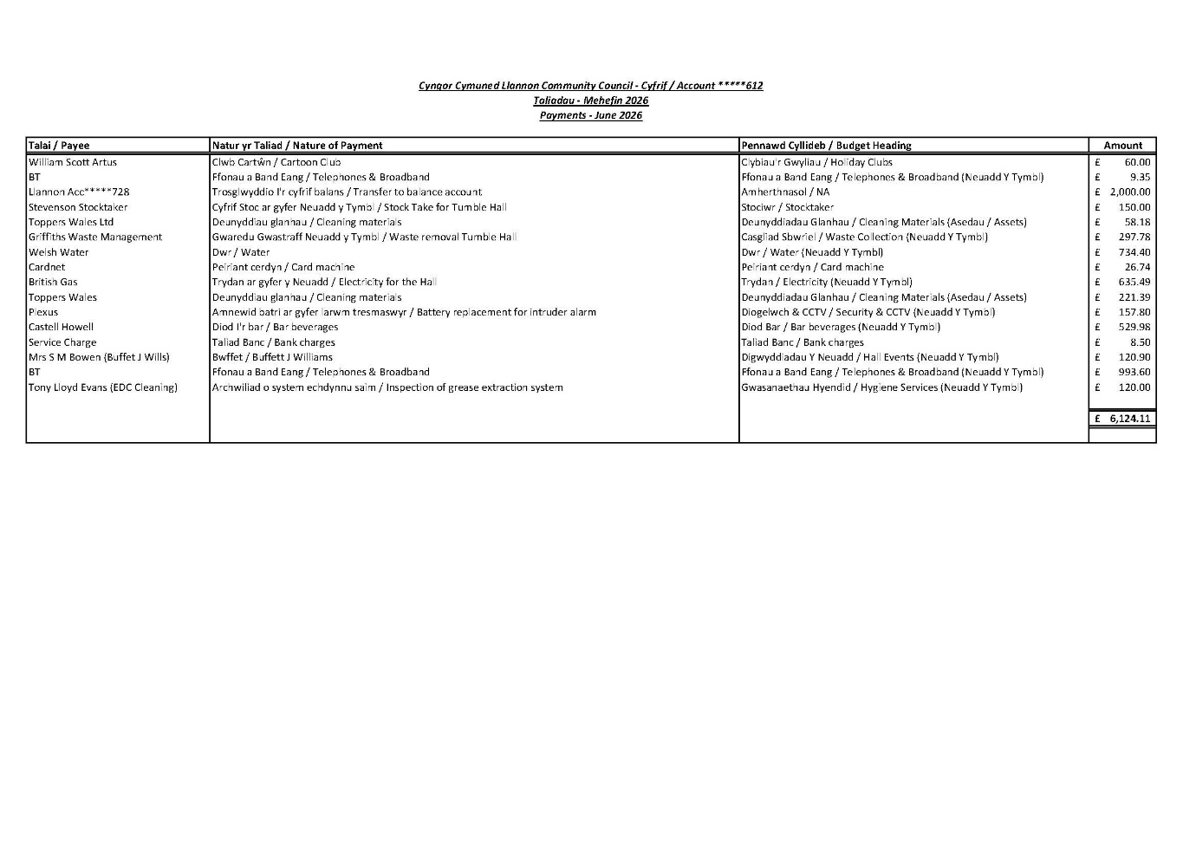
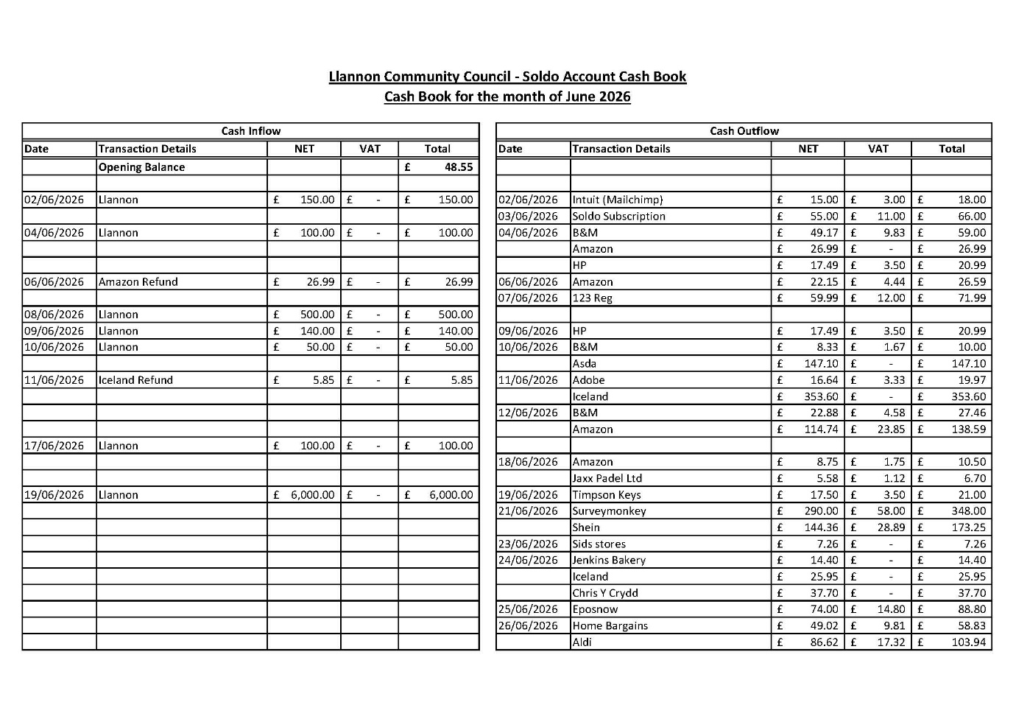
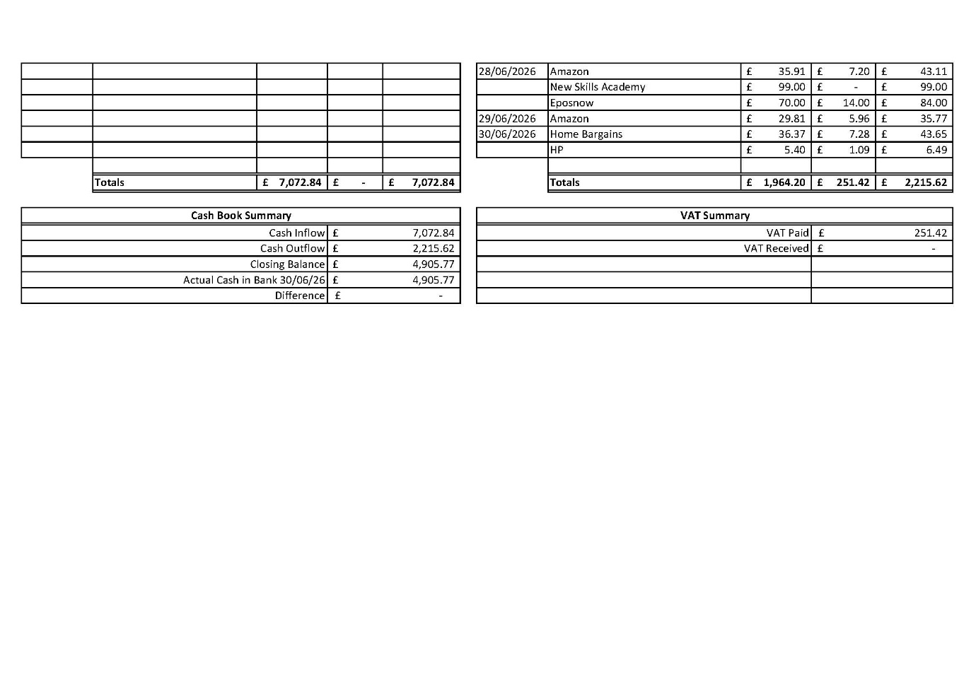
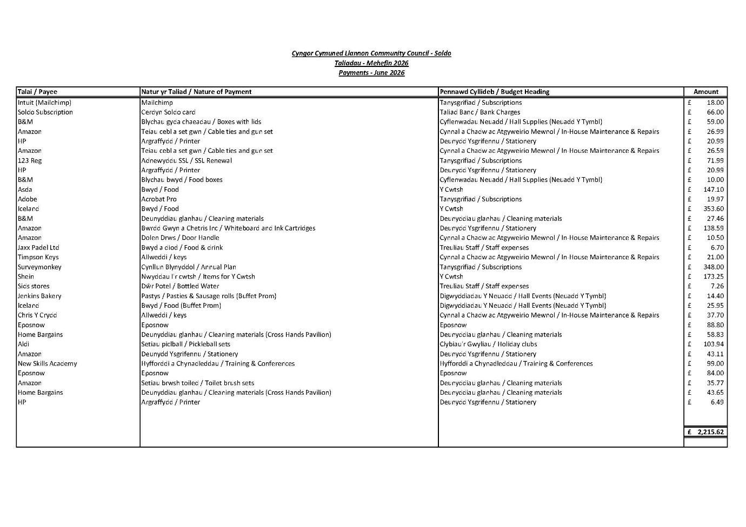
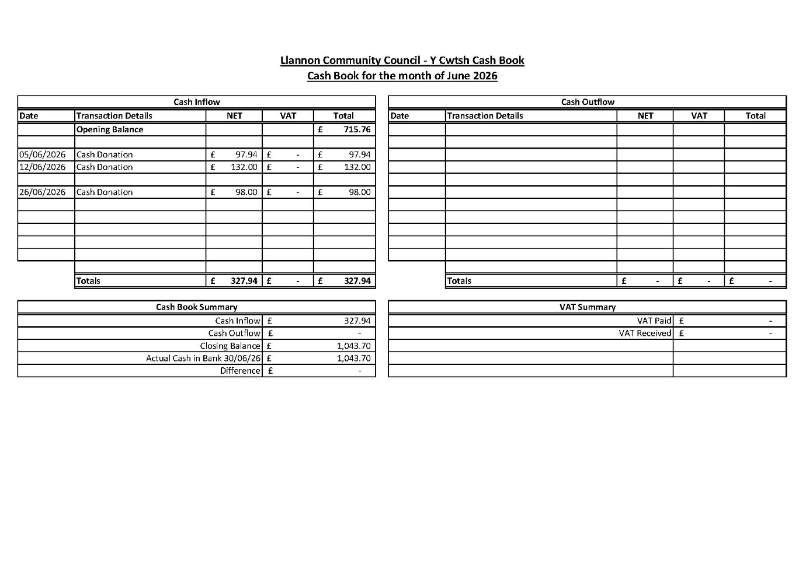
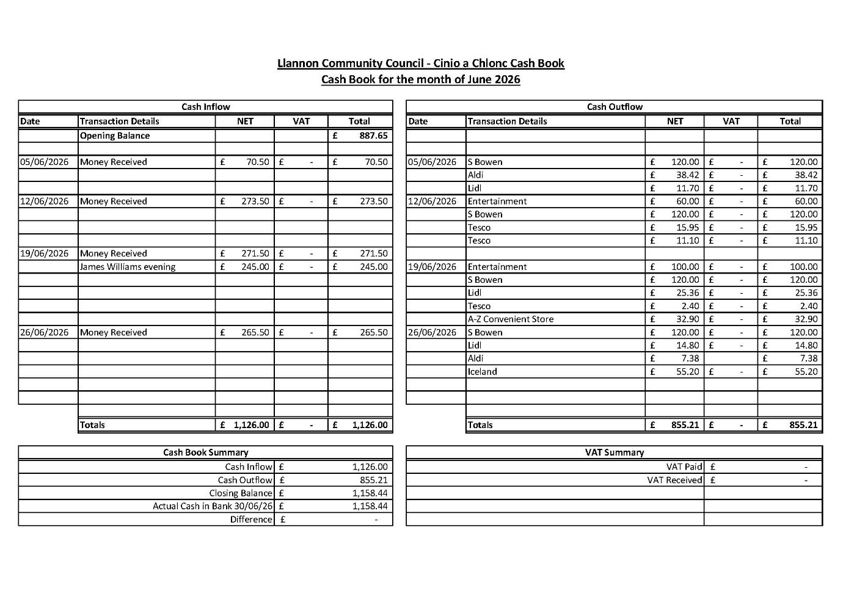
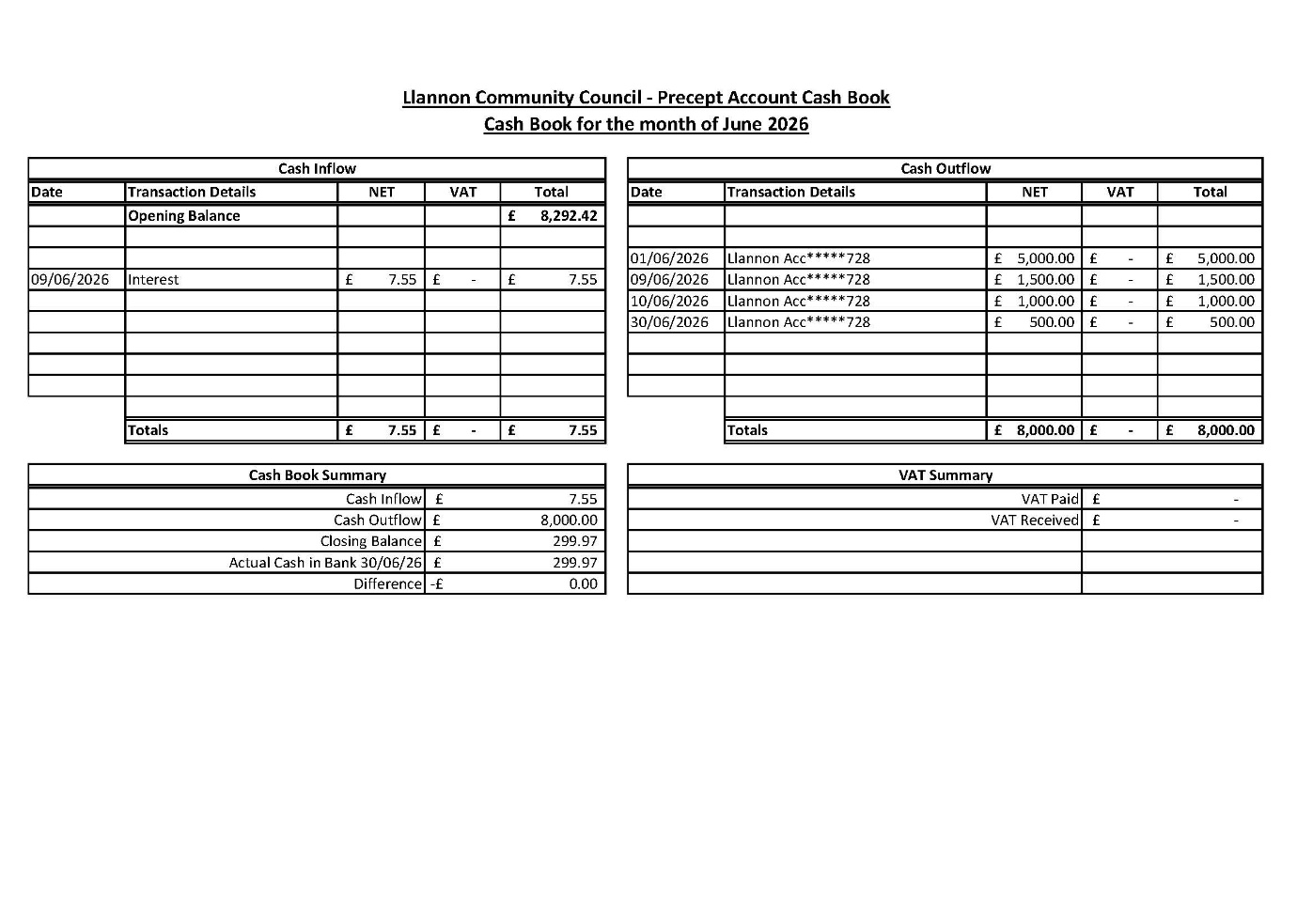
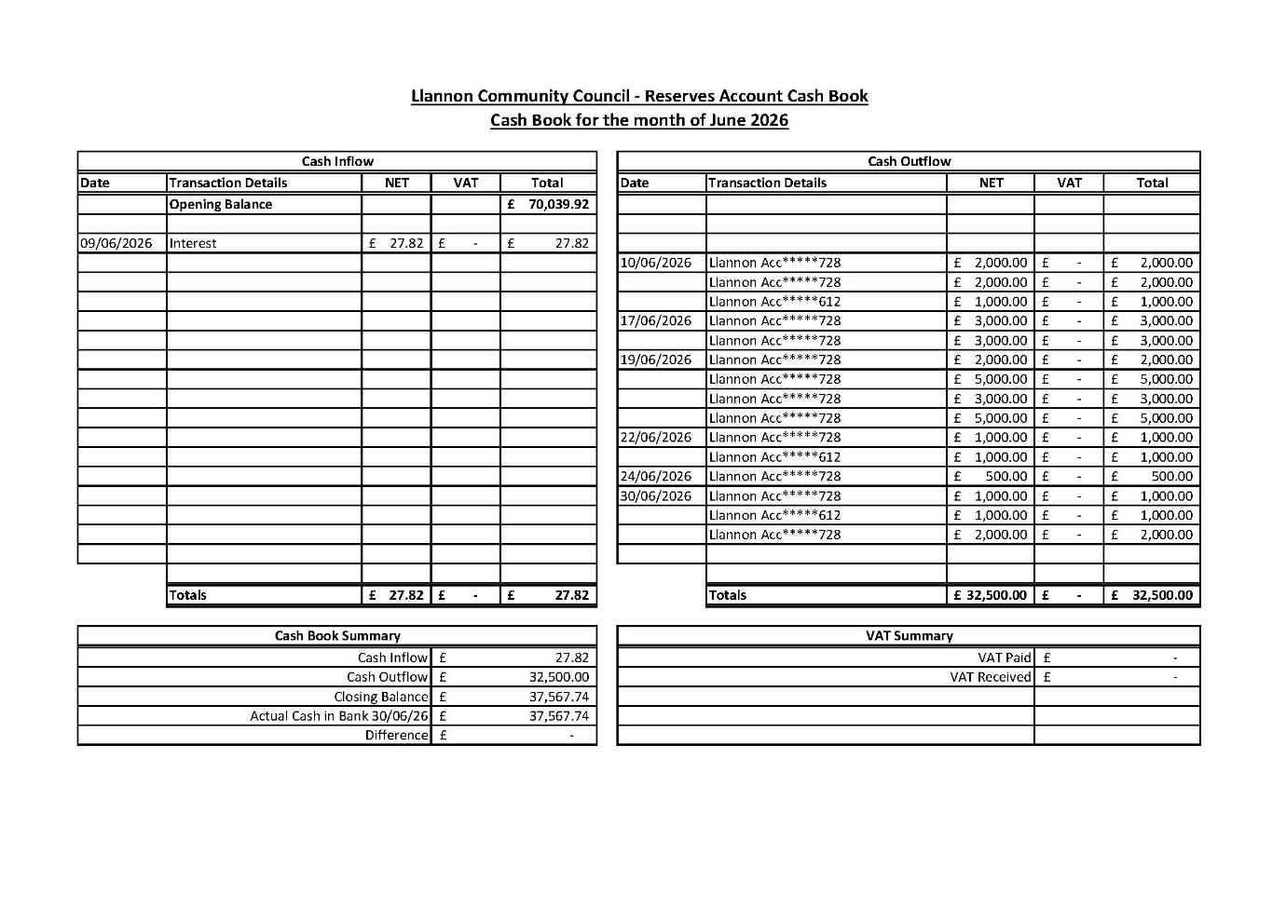
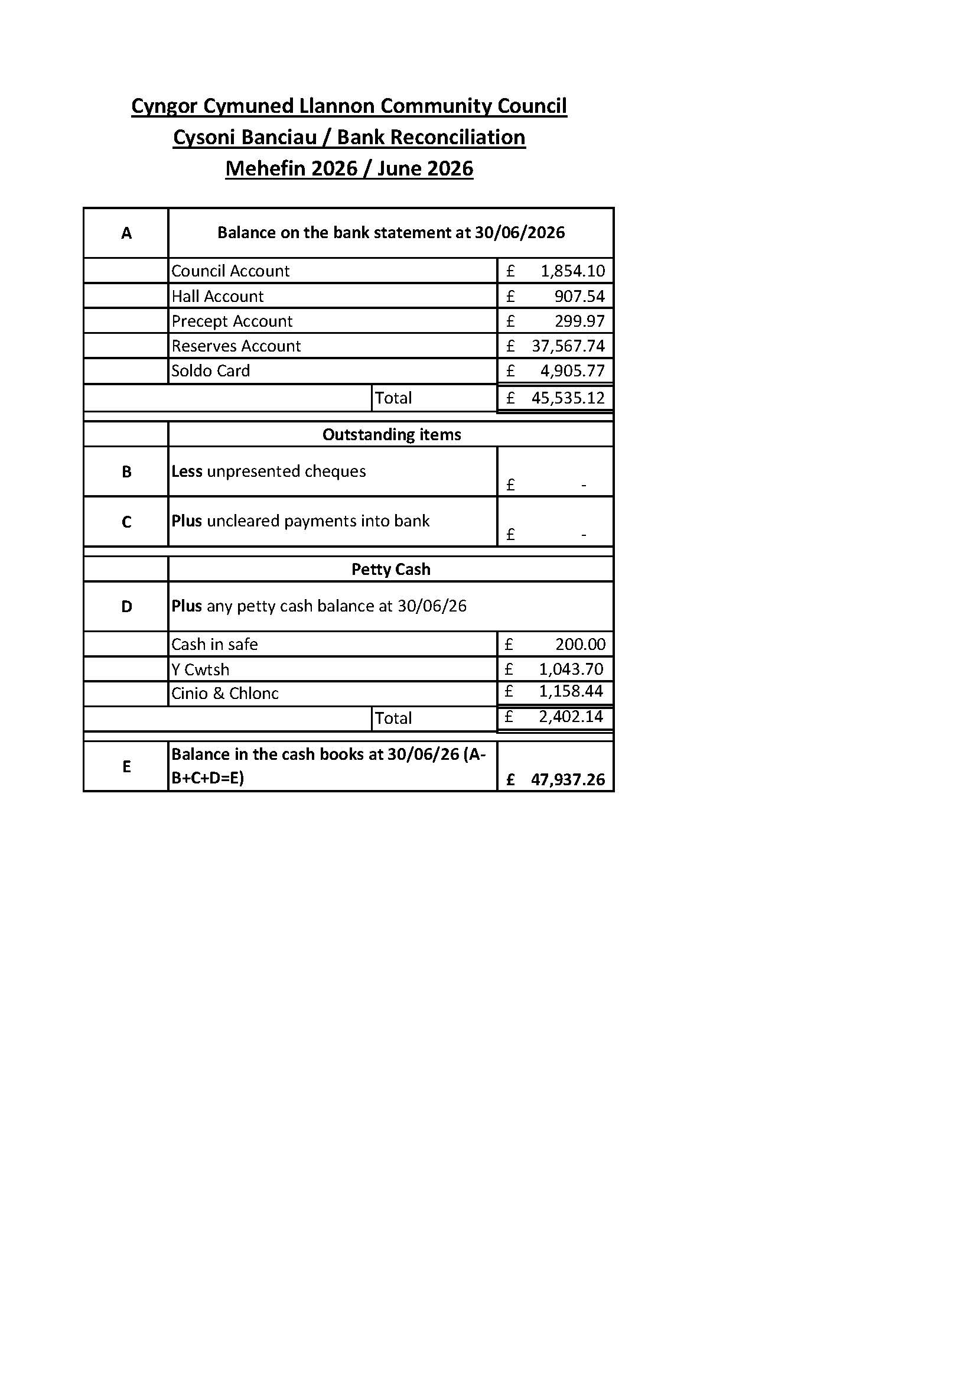
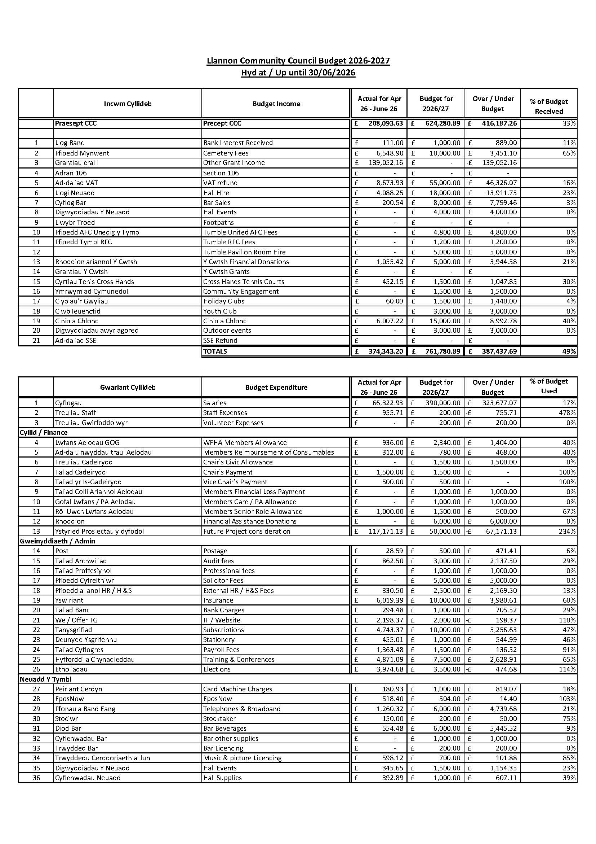
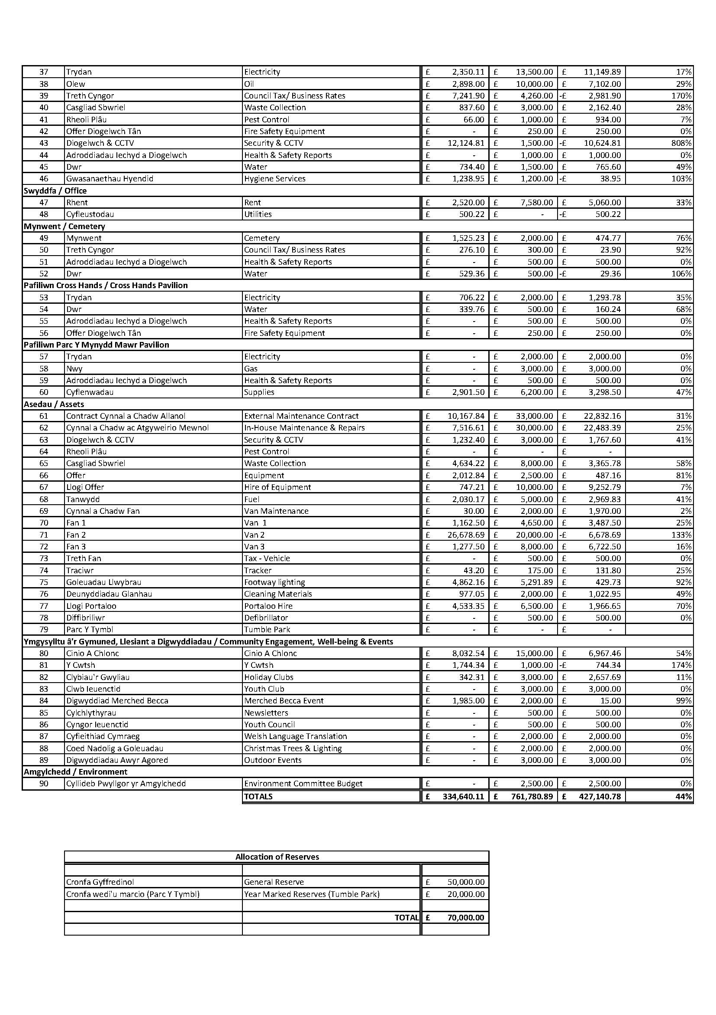

Cofnodion Pwyllgor Cyllid Cyngor Cymuned Llannon
Dydd Llun 10 Awst 2026 am 5.00yp Drwy Teams

Dechreuodd y cyfarfod am 5.00yp

Cofnod Rhif 11 – Aelodau’n bresennol.

Cllr. R. Lloyd Davies (RD)
Cllr. J. Owen (JO)
Cllr. J. Burree (JB)
Cllr. J. Anderson (JA)

Hefyd yn bresennol:

Miss Ff. Davies – Dirprwy Brif Swyddog & RFO (FD)

Cofnod Rhif 12 – Ymddiheuriadau ac esboniadau am absenoldeb.

Doedd dim ymddiheuriadau am absenoldeb.

Cofnod Rhif 13 – Datganiadau o Fuddiant.

Dim datganiadau newydd o fuddiant.

Cofnod Rhif 14 – Adolygu Llyfrau Arian y Cyngor ar gyfer Mehefin 2026.

Cylchredwyd y llyfrau canlynol ymlaen llaw:

• Llyfr Arian Cyfrif y Cyngor – Mehefin 2026
• Llyfr Arian Cyfrif y Neuadd – Mehefin 2026
• Llyfr Arian y Rhagdreuliau – Mehefin 2026
• Llyfr Arian y Cronfeydd Wrth Gefn – Mehefin 2026
• Llyfr Arian Soldo – Mehefin 2026
• Llyfr Arian Y Cwtsh – Mehefin 2026
• Llyfr Arian Cinio a Chlonc – Mehefin 2026

Trafodwyd pob un gan yr aelodau.

Cynigiodd JB gadarnhau’r llyfrau; eiliwyd gan RD; derbyniwyd yn unfrydol.

Penderfynwyd cadarnhau pob un o’r llyfrau uchod ar gyfer Mehefin 2026.

Cofnod Rhif 15 – Derbyn Cymod Banciau Mehefin 2026.

Cylchredwyd ymlaen llaw.

Cynigiodd RD ei dderbyn; eiliwyd gan JB; derbyniwyd yn unfrydol.

Penderfynwyd bod Cymod Banciau Mehefin 2026 wedi’i dderbyn a’i wirio.

5.05yp ymunodd Y Cynghorydd J. Anderson a’r chyfarfod.

Cofnod Rhif 16 – Derbyn Taflen Monitro Cyllideb hyd at 30/06/2026.

Cylchredwyd ymlaen llaw.

Cynigiodd RD ei dderbyn; eiliwyd gan JB; derbyniwyd yn unfrydol.

Penderfynwyd bod y ddogfennau wedi’i derbyn a’i gwirio.

Cofnod Rhif 17 – Derbyn Adroddiad Ariannol Chwarter 1.

Cylchredwyd yr adroddiad ymlaen llaw.

Adroddodd yr RFO y balansau banc ar 30 Mehefin 2026:
• Cyfrif y Cyngor: £1,854.10
• Cyfrif y Neuadd: £907.54
• Cyfrif y Rhagdreuliau: £299.97
• Cyfrif y Cronfeydd Wrth Gefn: £37,567.74

Cynigiodd JA ei dderbyn; eiliwyd gan JB; derbyniwyd yn unfrydol.

Penderfynwyd bod Adroddiad Chwarter 1 wedi’i dderbyn a’i wirio.

Cofnod Rhif 18 – Dyddiad y cyfarfod nesaf.

Cytunwyd i gynnal y cyfarfod nesaf ar Dydd Mawrth 22 Medi 2026.

Daeth y cyfarfod i ben am 5.16 yp

