Cyngor Cymuned Llannon Community Council
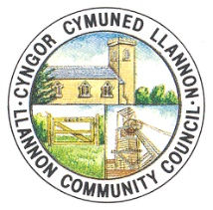

Minutes of the Finance Committee of Llannon Community Council
Monday 13th July 2026 at 5.00pm
Held via Teams
Meeting commenced at 5.00pm
The Chair, Cllr. J. Owen presided over the meeting.

Minute No. 1 – To appoint a Chair of the Finance Committee for 2026 – 2027.

RD proposed that Cllr. J. Owen is elected Chair of the Finance Committee for 2026-2027. JB seconded the proposal. All members present in favour.

Resolved that Cllr. J. Owen is the Chair of the Finance Committee for 2026-2027.

Minute No. 2 – Members Present.

Cllr. R. Lloyd Davies (RD)
Cllr. J. Owen (JO)
Cllr. J. Burree (JB)

Also Present:

Miss Ff. Davies – Deputy Chief Officer & RFO (FD)

Minute No. 3 – Apologies and reasons for absence.

Cllr. J. Anderson (JA) – Work Commitments.

Minute No. 4 – Declarations of Interests.

There were no new declarations of interests.
Minute No. 5 – To review the Council’s Cashbooks and Payments for March 2026.

The RFO previously circulated the following Cashbooks and Payments to all members of the Finance Committee via email:
- Soldo Account Cashbook and Payments March 2026.
- Council Account Cashbook and Payments March 2026.
- Hall Account Cashbook and Payments March 2026.
- Precept Account Cashbook March 2026.
- Reserves Account Cashbook March 2026.
- Y Cwtsh Cashbook March 2026.
- Cinio a Chlonc Cashbook March 2026.

The Chair asked the members present if there were any questions with regards to the above Cashbooks and Payments. The members present discussed all the Cashbooks and Payments presented to them.

JB proposed that the Finance Committee ratify the above Cashbooks and Payments as previously circulated via email from the RFO. RD seconded the proposal. All members present in favour.

Resolved that the Soldo Account Cashbook and Payments for March 2026, Council Account Cashbook and Payments for March 2026, Hall Account Cashbook and Payments for March 2026, Precept Account Cashbook for March 2026, Reserve Account Cashbook for March 2026, Y Cwtsh Cashbook for March 2026, and Cinio a Chlonc Cashbook for March 2026 are ratified.

Minute No. 6 – To review the Council’s Cashbooks and Payments for April 2026.

The RFO previously circulated the following Cashbooks and Payments to all members of the Finance Committee via email:
- Soldo Account Cashbook and Payments April 2026.
- Council Account Cashbook and Payments April 2026.
- Hall Account Cashbook and Payments April 2026.
- Precept Account Cashbook April 2026.
- Reserves Account Cashbook April 2026.
- Y Cwtsh Cashbook April 2026.
- Cinio a Chlonc Cashbook April 2026.

The Chair asked the members present if there were any questions with regards to the above Cashbooks and Payments. The members present discussed all the Cashbooks and Payments presented to them.

RD proposed that the Finance Committee ratify the above Cashbooks and Payments as previously circulated via email from the RFO. JB seconded the proposal. All members present in favour.

Resolved that the Soldo Account Cashbook and Payments for April 2026, Council Account Cashbook and Payments for April 2026, Hall Account Cashbook and Payments for April 2026, Precept Account Cashbook for April 2026, Reserve Account Cashbook for April 2026, Y Cwtsh Cashbook for April 2026, and Cinio a Chlonc Cashbook for April 2026 are ratified.

Minute No. 7 – To review the Council’s Cashbooks and Payments for May 2026.

The RFO previously circulated the following Cashbooks and Payments to all members of the Finance Committee via email:
- Soldo Account Cashbook and Payments May 2026.
- Council Account Cashbook and Payments May 2026.
- Hall Account Cashbook and Payments May 2026.
- Precept Account Cashbook May 2026.
- Reserves Account Cashbook May 2026.
- Y Cwtsh Cashbook May 2026.
- Cinio a Chlonc Cashbook May 2026.

The Chair asked the members present if there were any questions with regards to the above Cashbooks and Payments. The members present discussed all the Cashbooks and Payments presented to them.

JB proposed that the Finance Committee ratify the above Cashbooks and Payments as previously circulated via email from the RFO. RD seconded the proposal. All members present in favour.

Resolved that the Soldo Account Cashbook and Payments for May 2026, Council Account Cashbook and Payments for May 2026, Hall Account Cashbook and Payments for May 2026, Precept Account Cashbook for May 2026, Reserve Account Cashbook for May 2026, Y Cwtsh Cashbook for May 2026, and Cinio a Chlonc Cashbook for May 2026 are ratified.
Minute No. 8 – To receive the Bank Reconciliation for March 2026, April 2026 and May 2026.

The RFO previously circulated the Bank Reconciliation for March 2026, April 2026 and May 2026 to all members of the Finance Committee via email.

RD proposed that the Finance Committee accept the Bank Reconciliation for March 2026, April 2026 and May 2026 as previously circulated via email from the RFO. JB seconded the proposal. All members present in favour.

Resolved that the Bank Reconciliation for March 2026, April 2026 and May 2026 have been received and verified by all members present.

Minute No. 9 – To receive the Budget Monitoring Spreadsheet up to 31/03/2026, 30/04/2026 and 31/05/2026.

The RFO previously circulated the Budget Monitoring Spreadsheet to all members of the Finance Committee via email.

RD proposed that the Finance Committee accept the Budgeting Monitoring Spreadsheet up to 31/03/2026, 30/04/2026 and 31/05/2026 as previously circulated via email from the RFO. JB seconded the proposal. All members present in favour.

Resolved that the Budget Monitoring Spreadsheet up to 31/03/2026, 30/04/2026 and 31/05/2026 have been received and verified by all members present.

Minute No. 10 – To agree the date of the next Finance Committee meeting.

It was agreed by all members present that the next meeting of the Finance Committee will be held on Monday 10th August 2026 at 5.00pm.

The Chair closed the meeting at 5.27pm

Signed ............................................................. Date ....................................

(Chair)
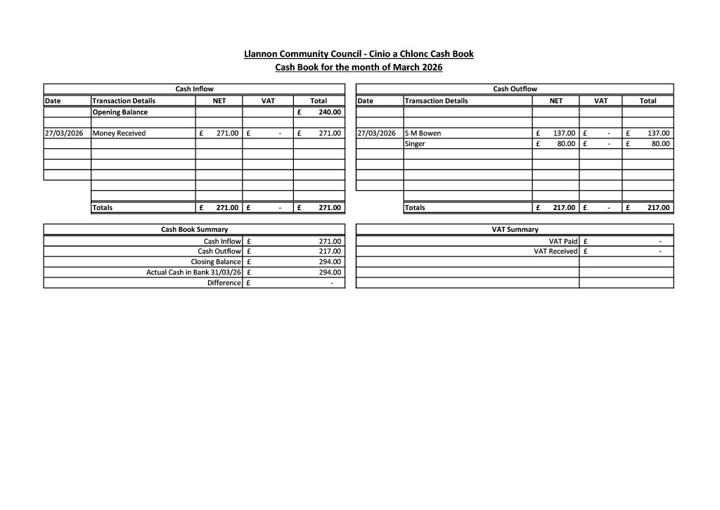
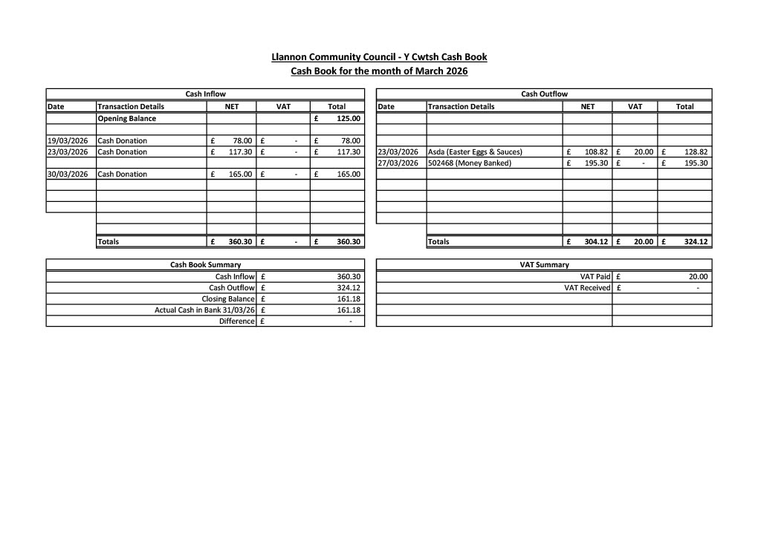
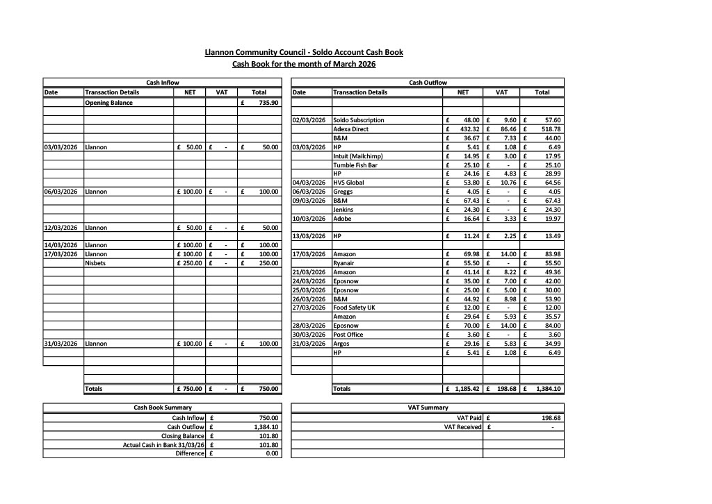
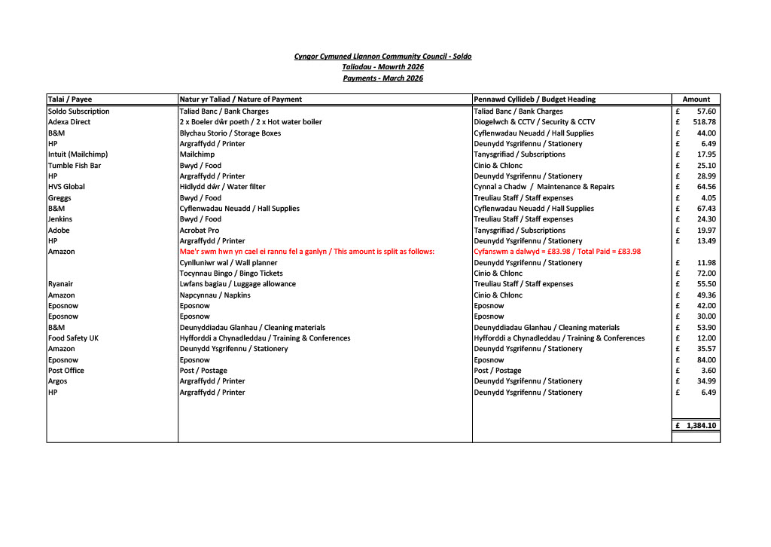

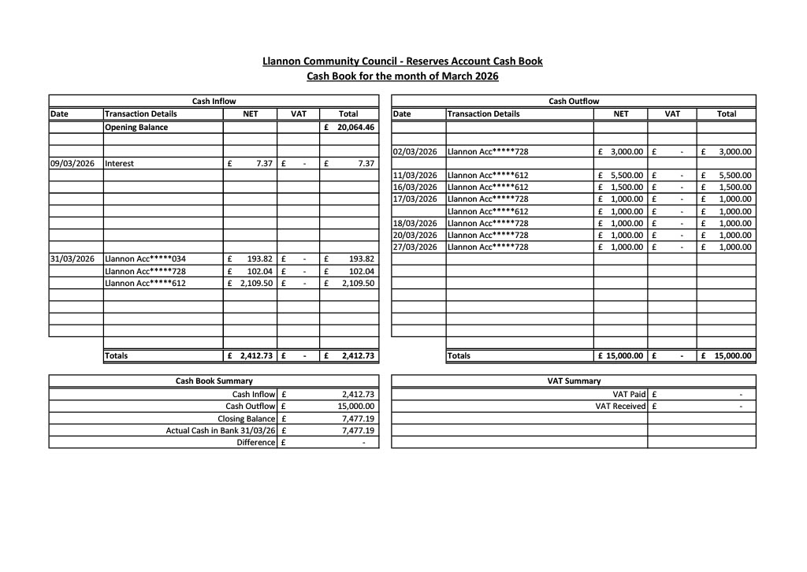
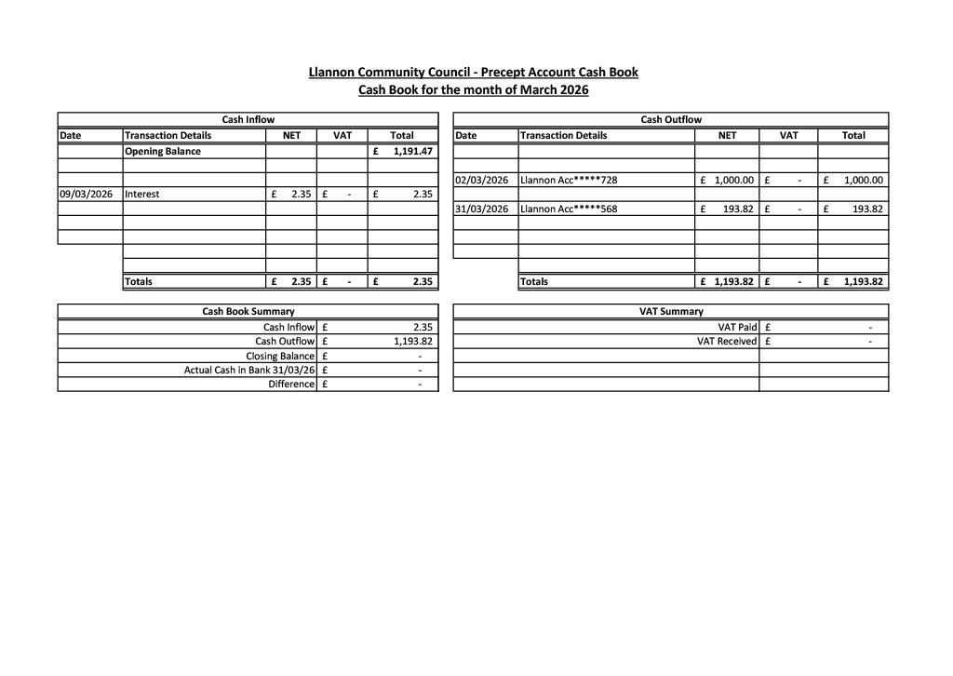
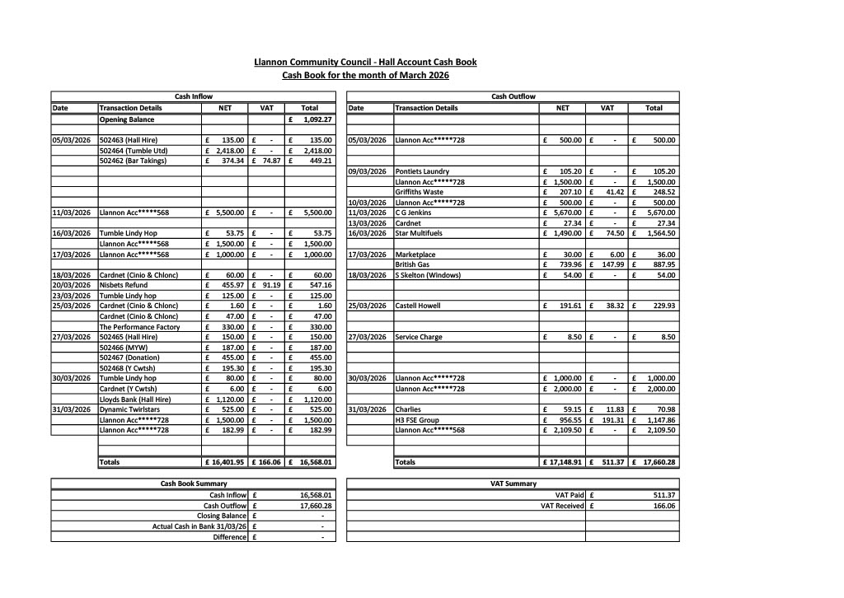
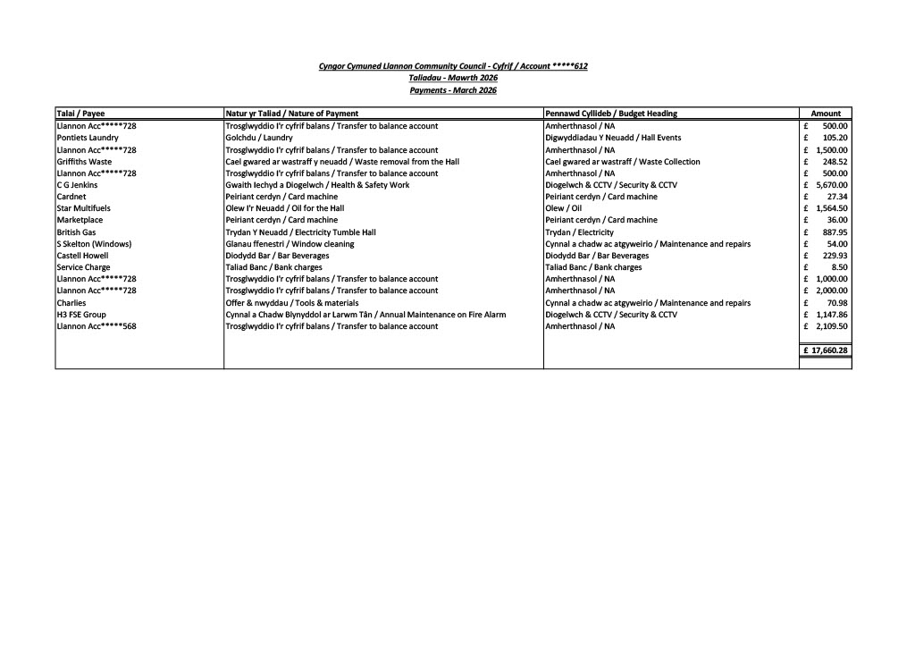

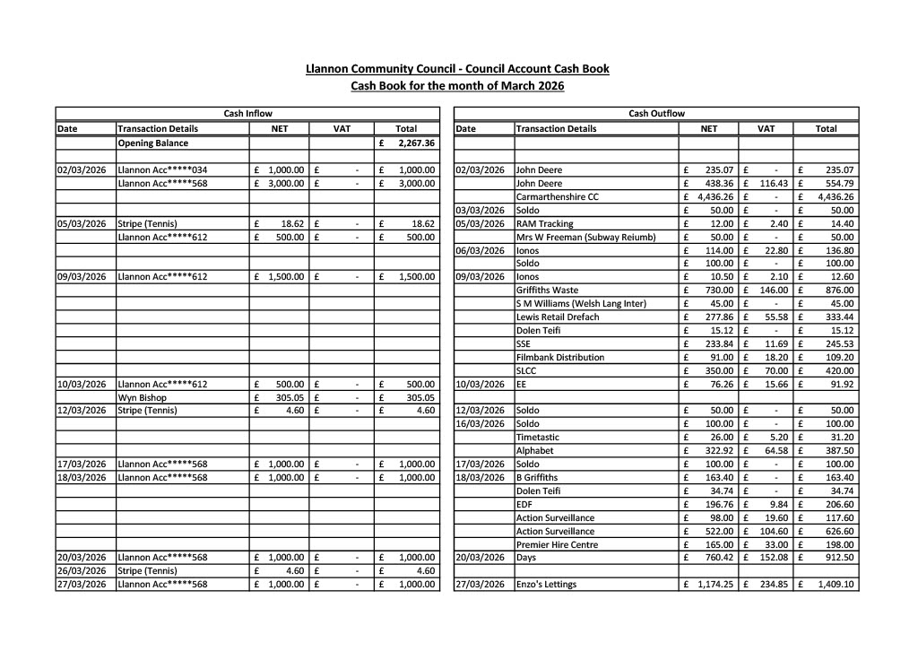

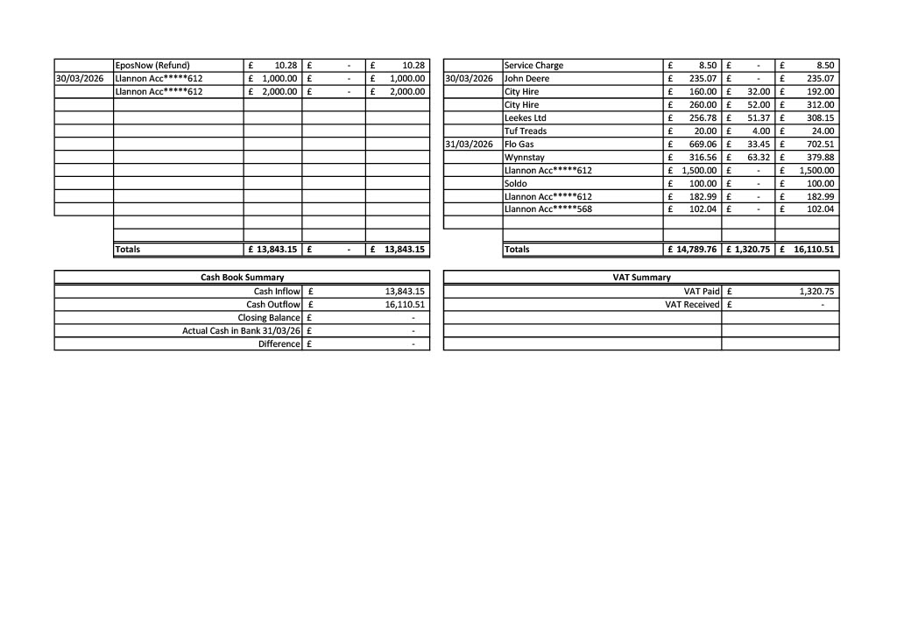

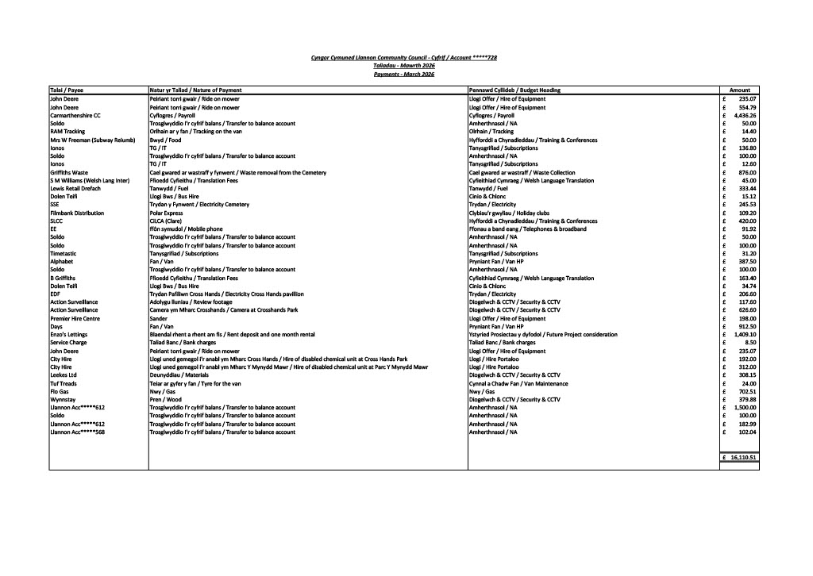

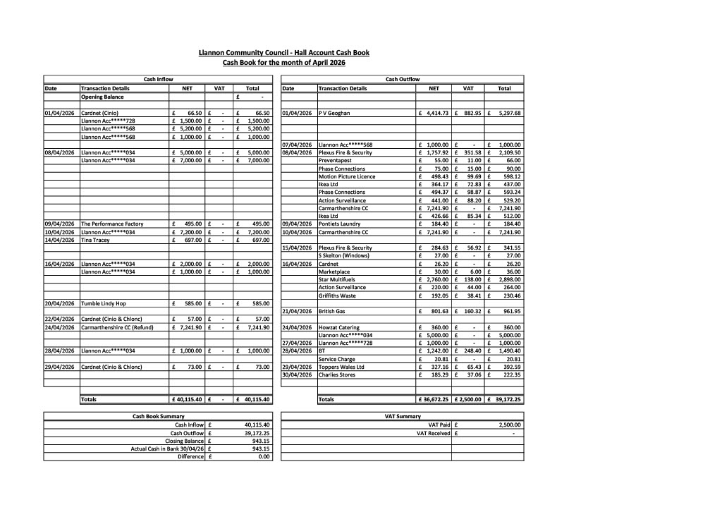
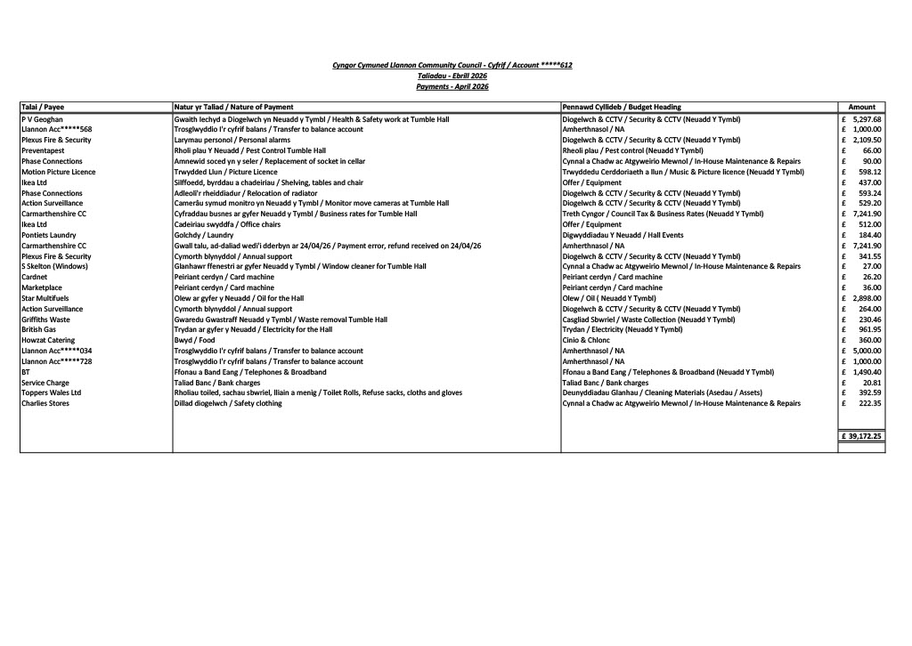

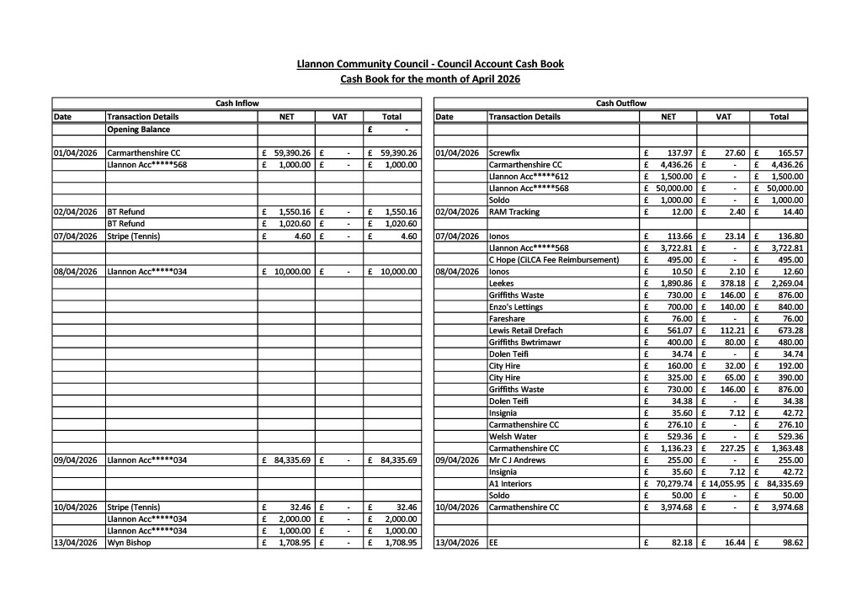
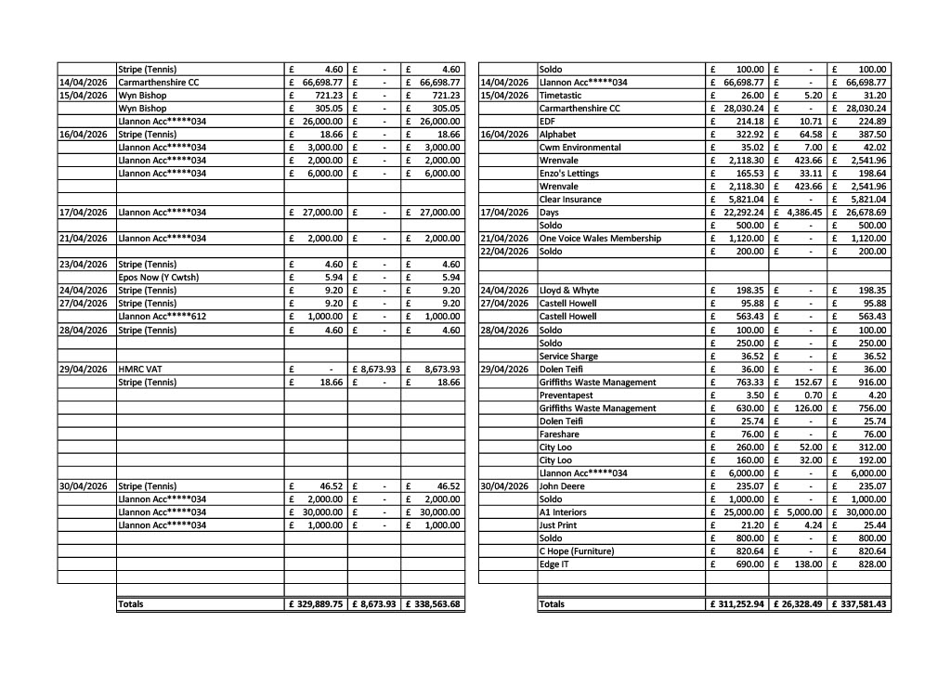
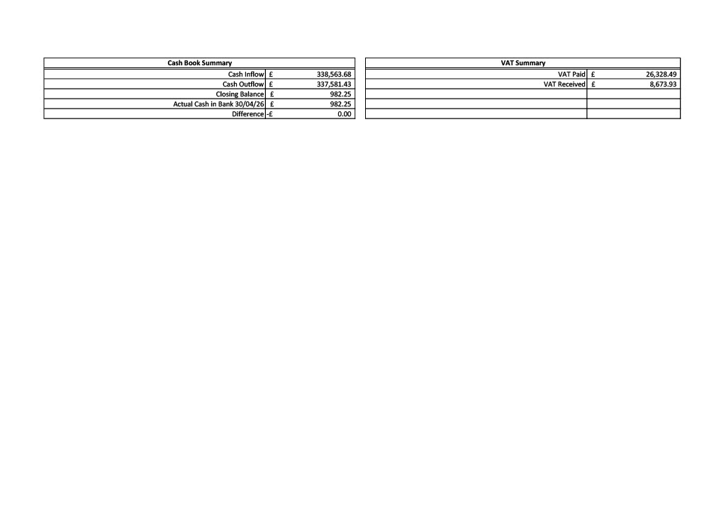
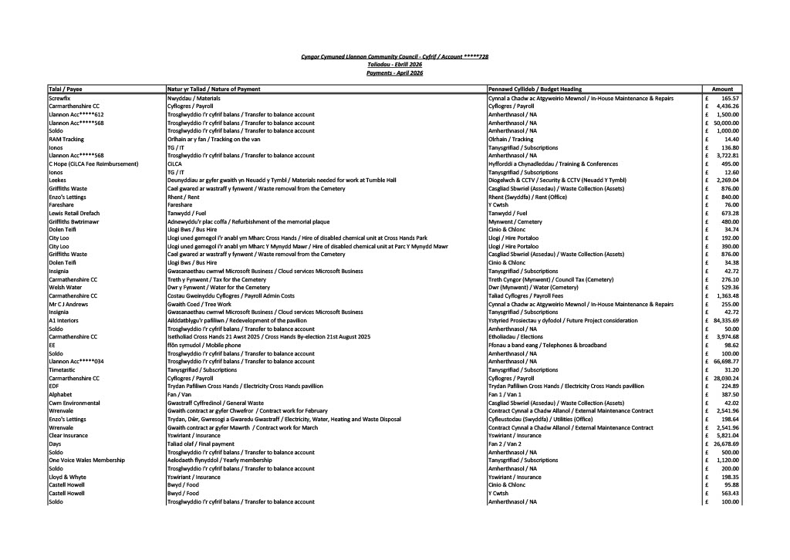
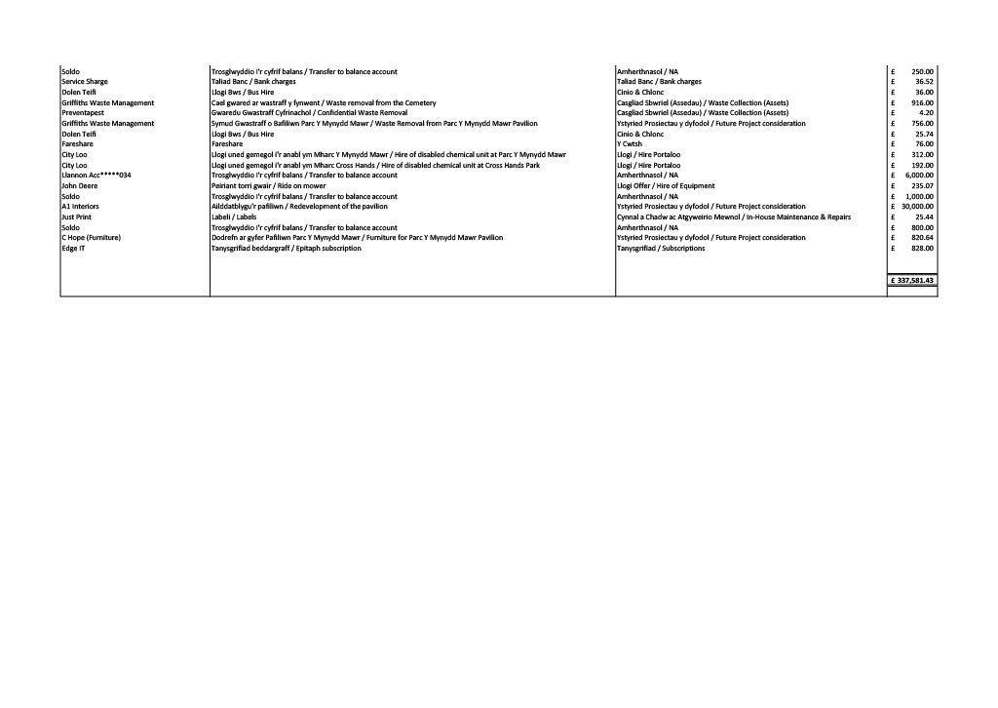

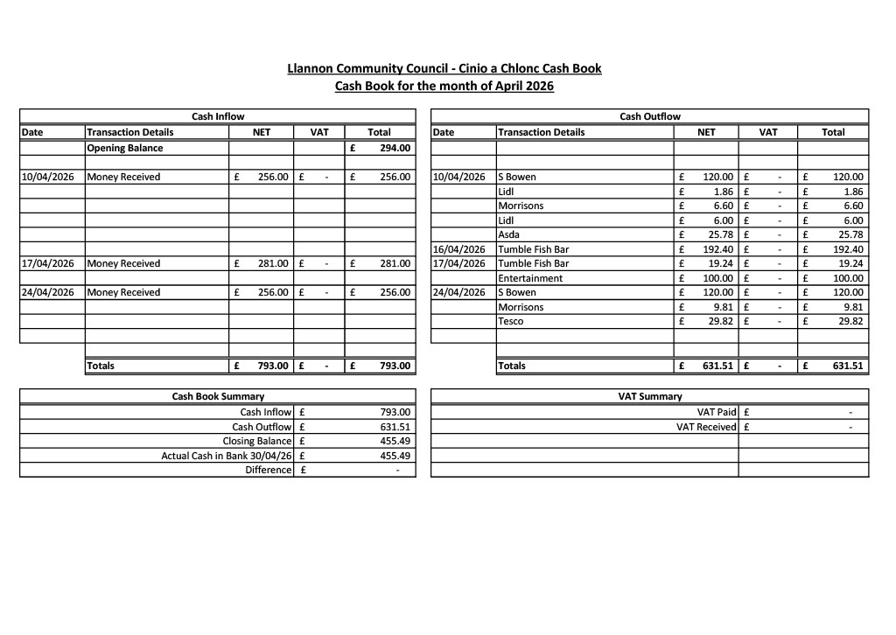
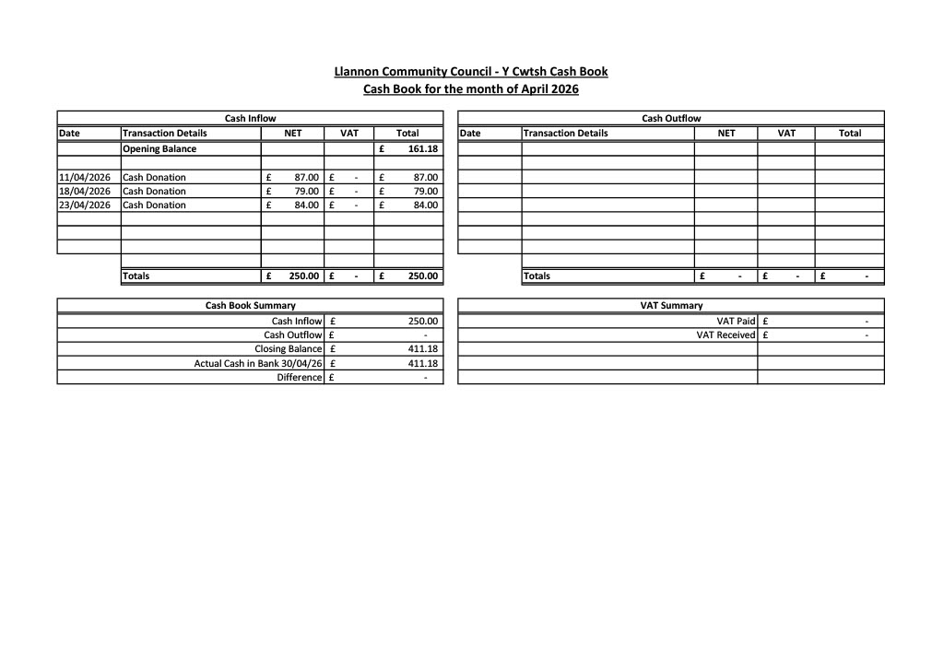
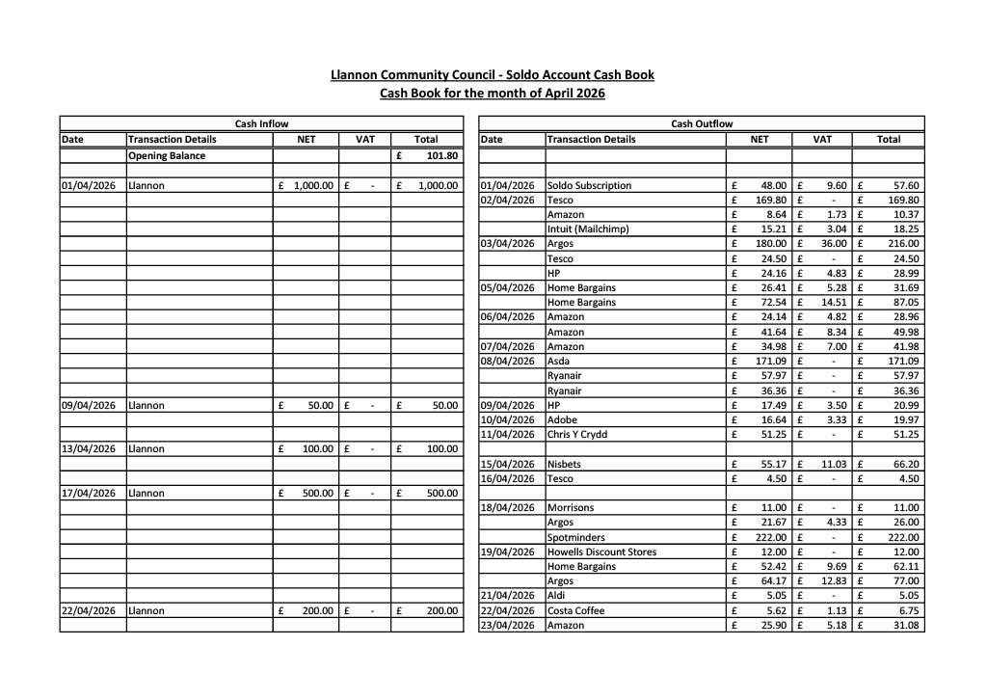
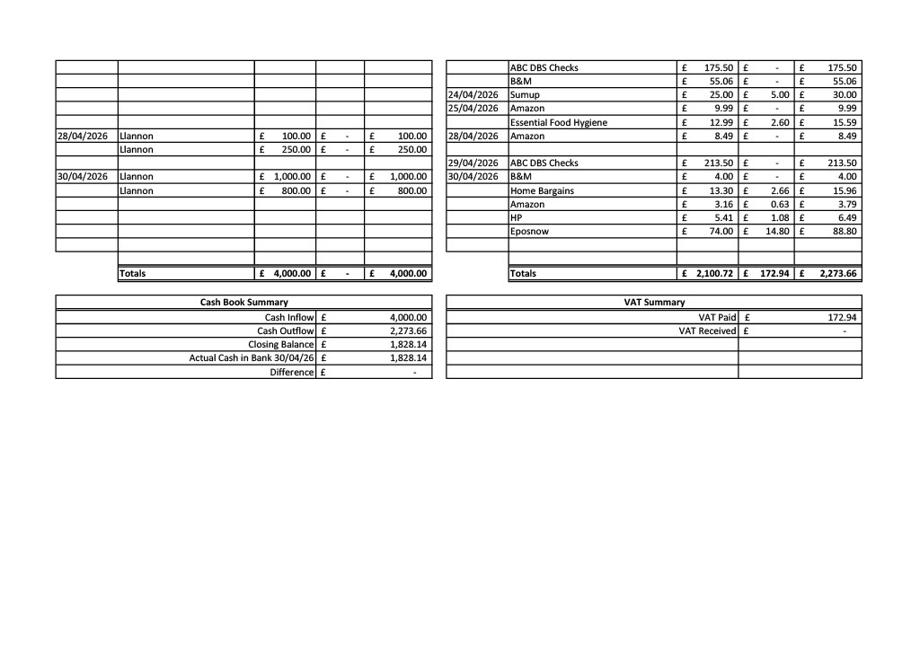
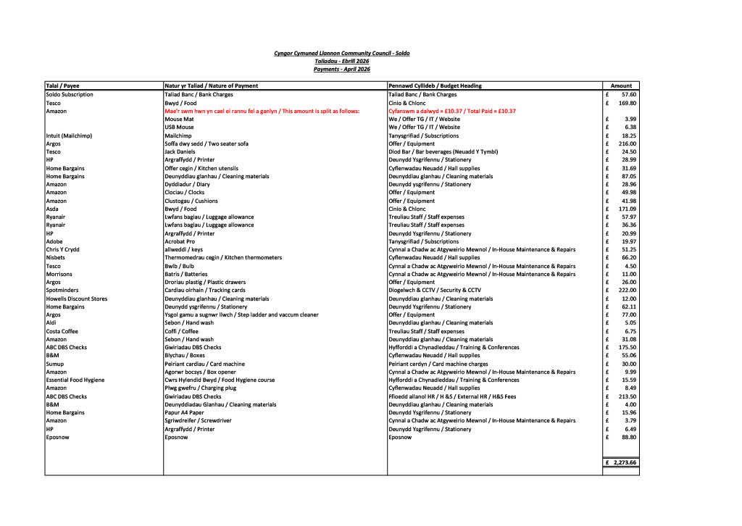

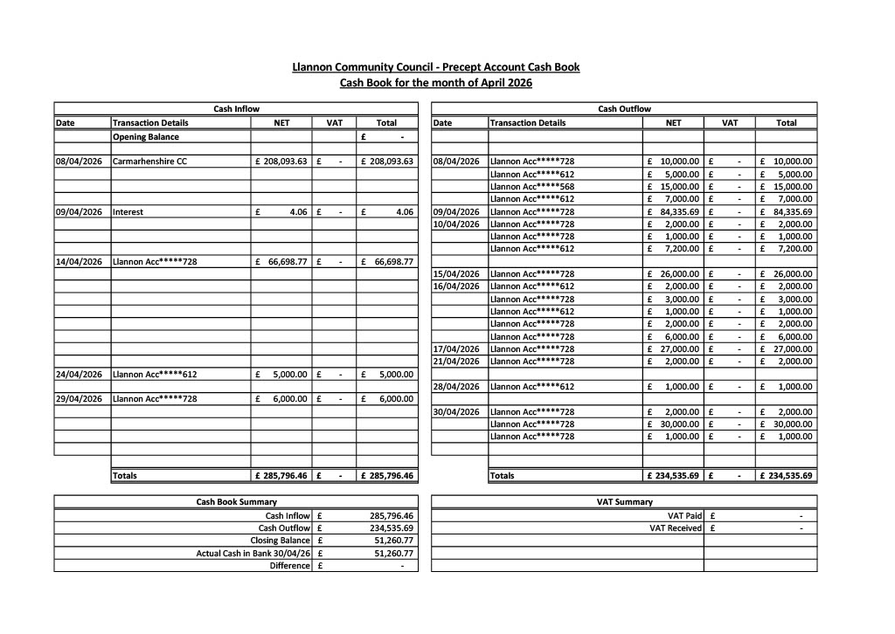
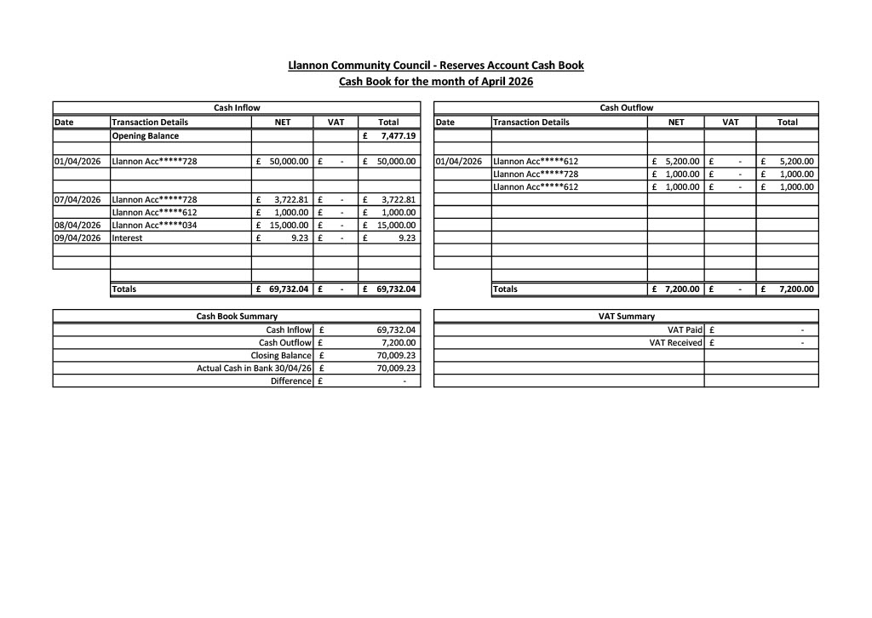
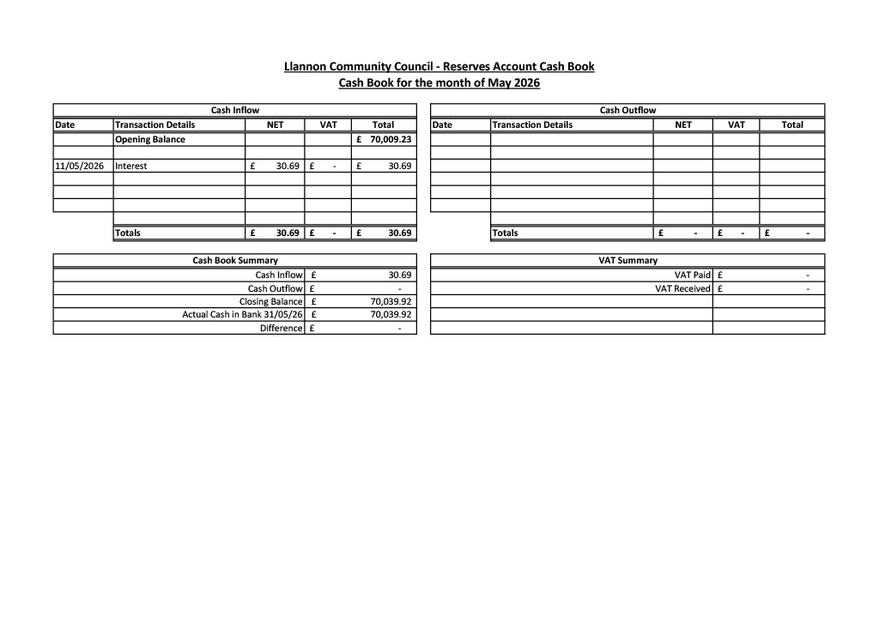
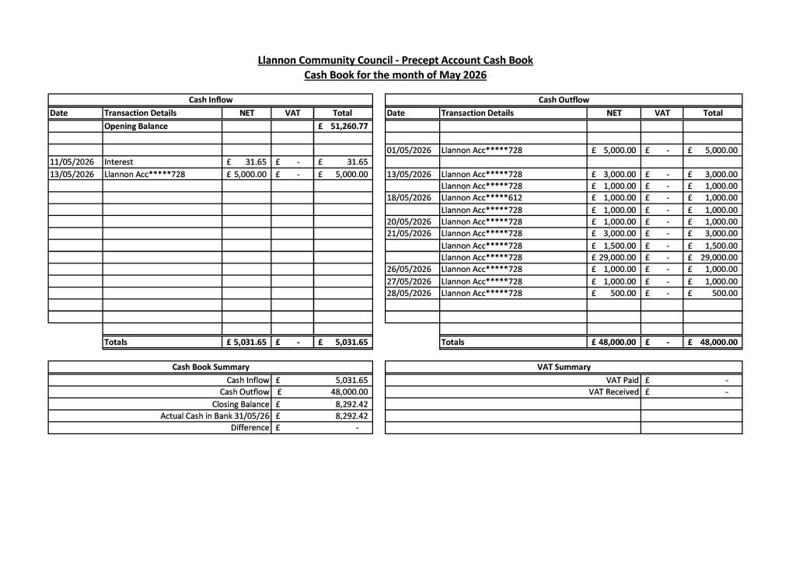

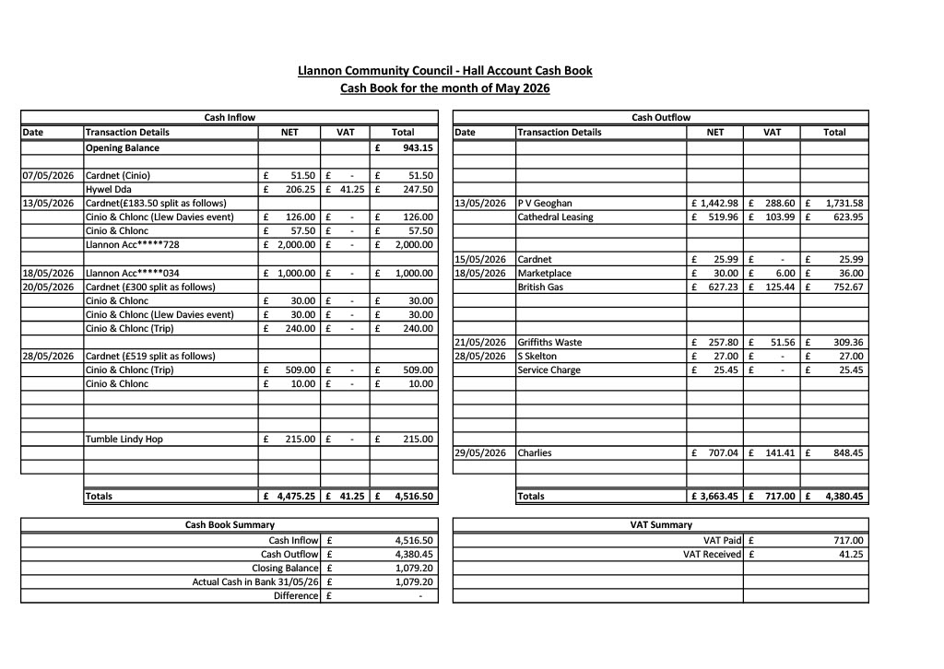

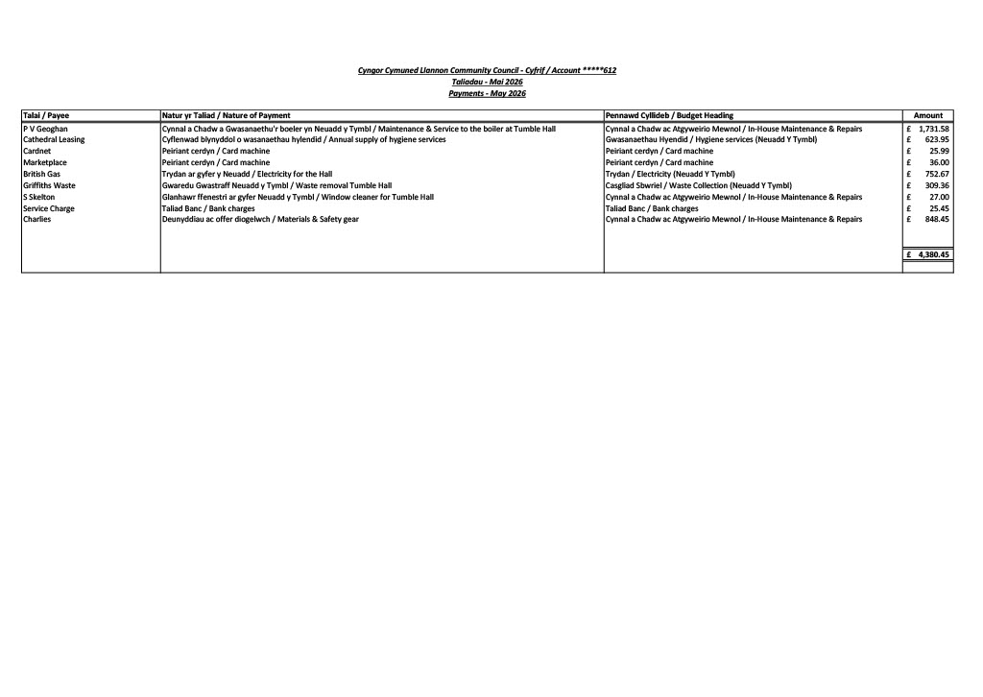

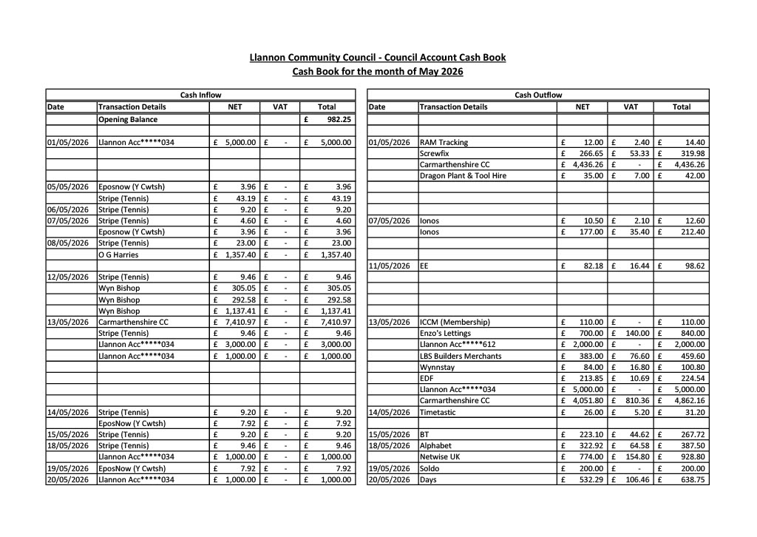
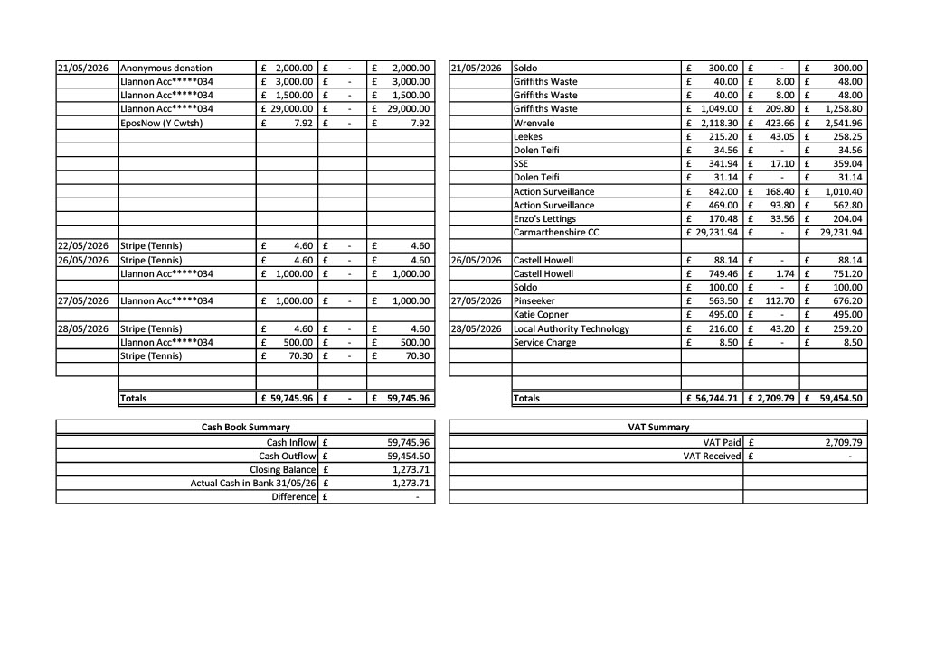
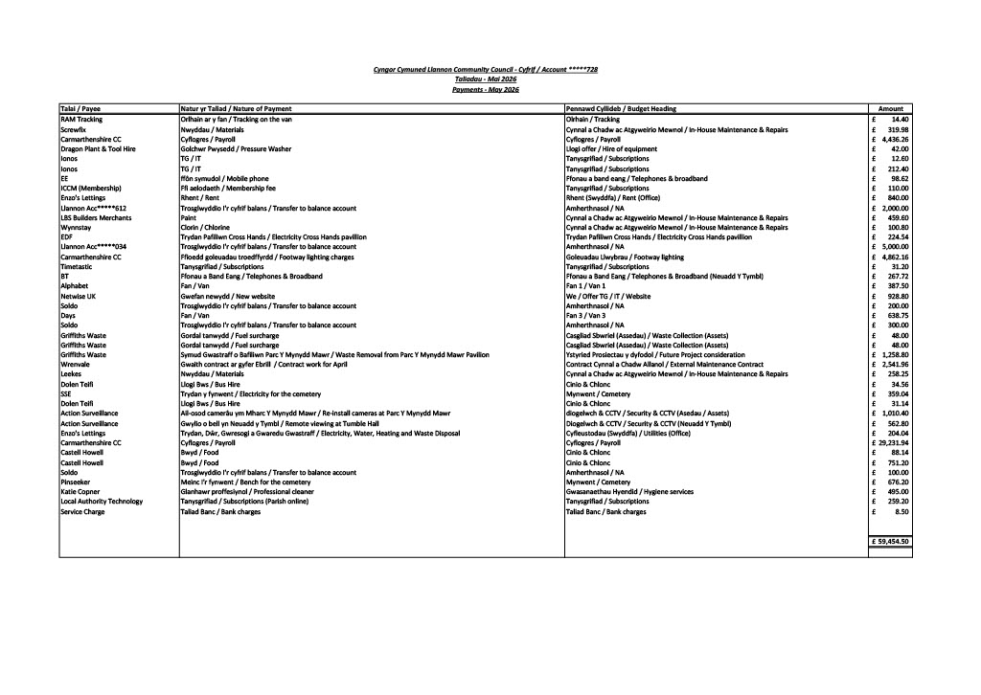

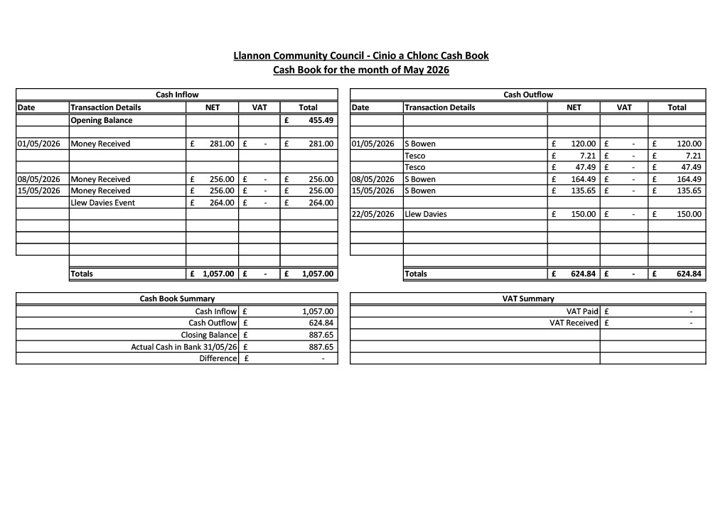
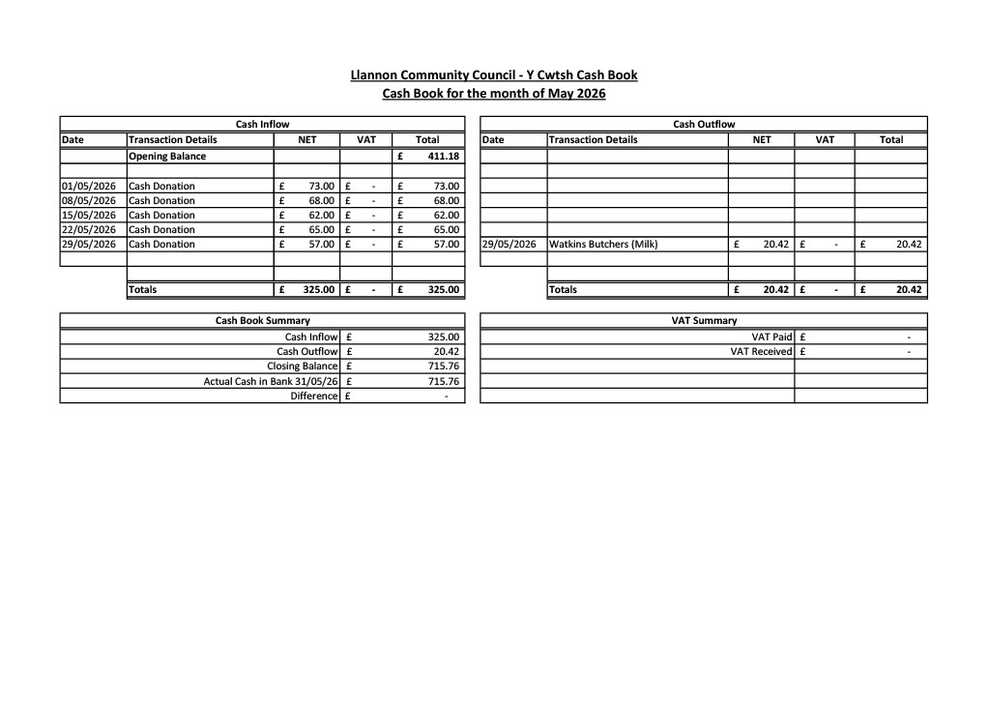
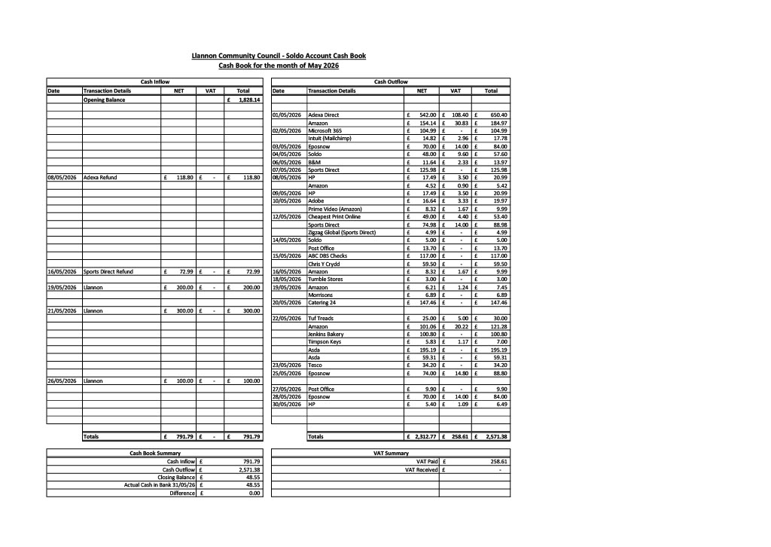

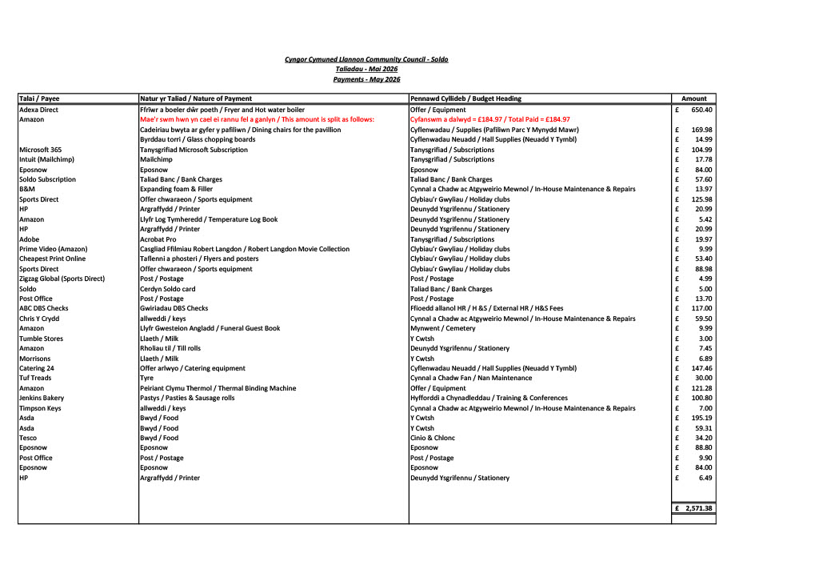

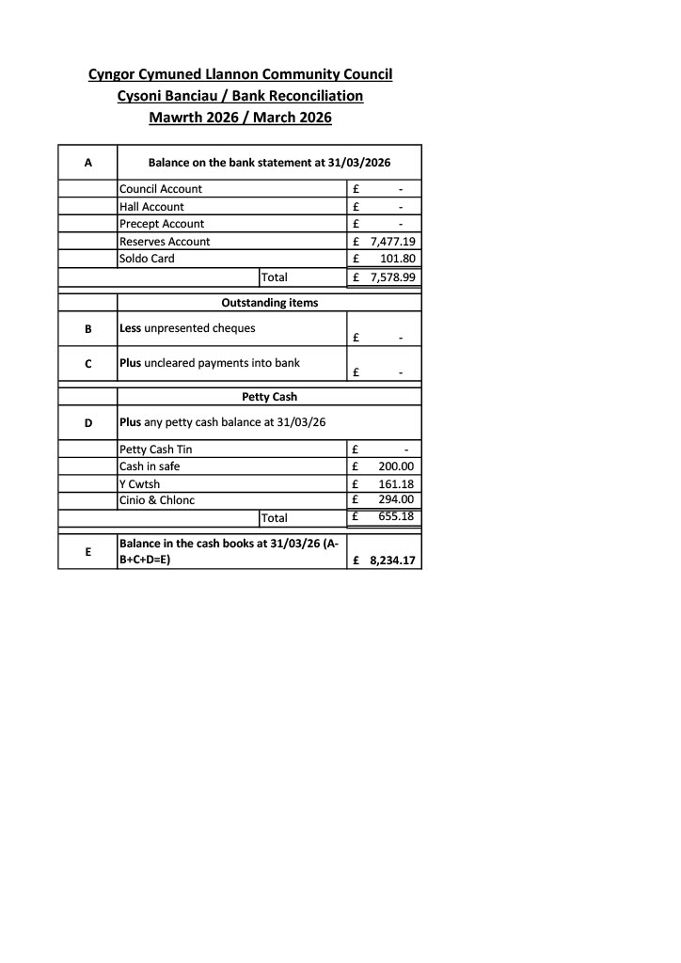
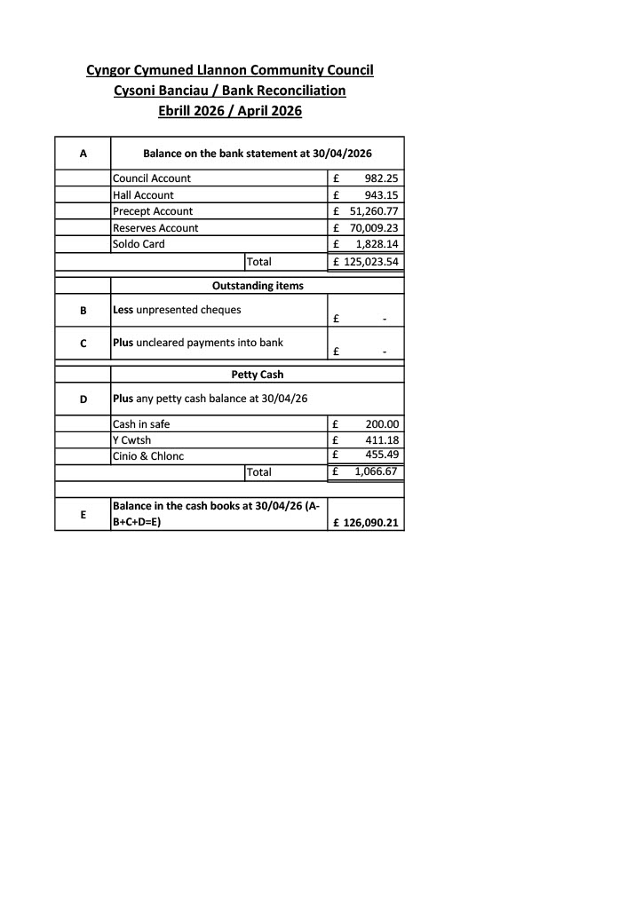
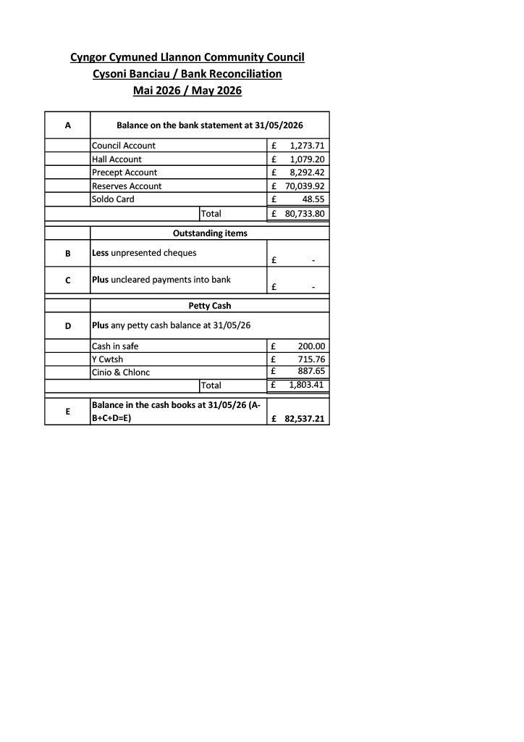
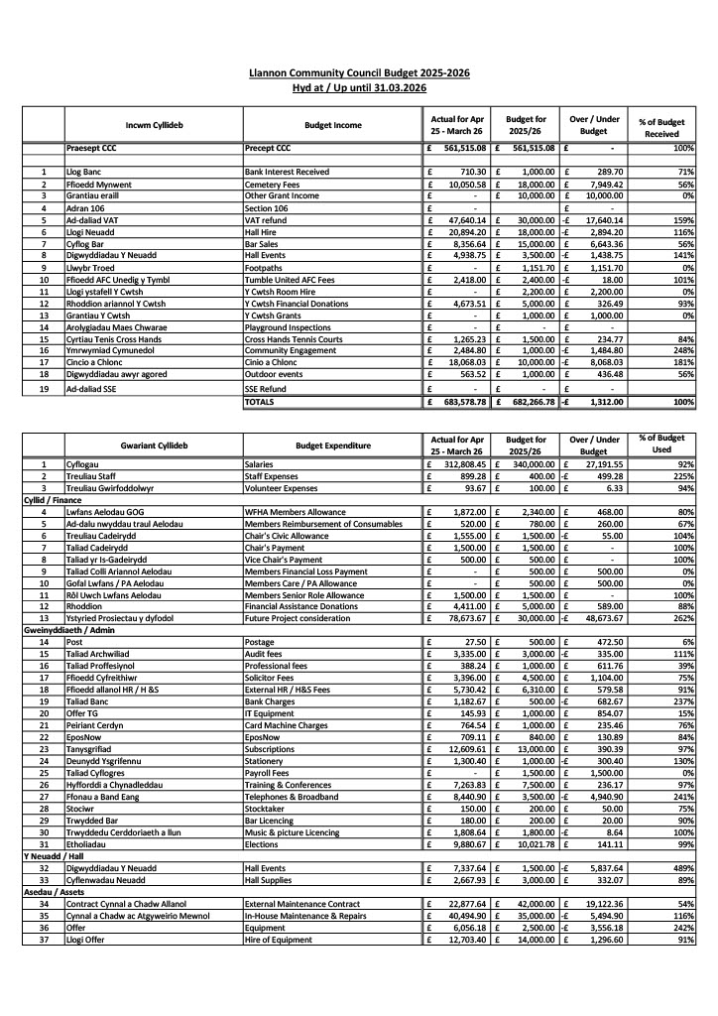
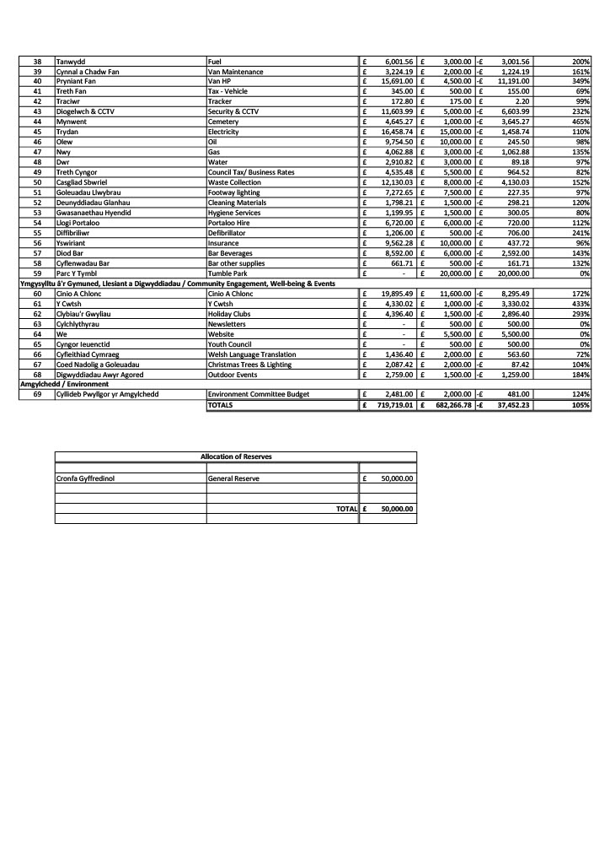
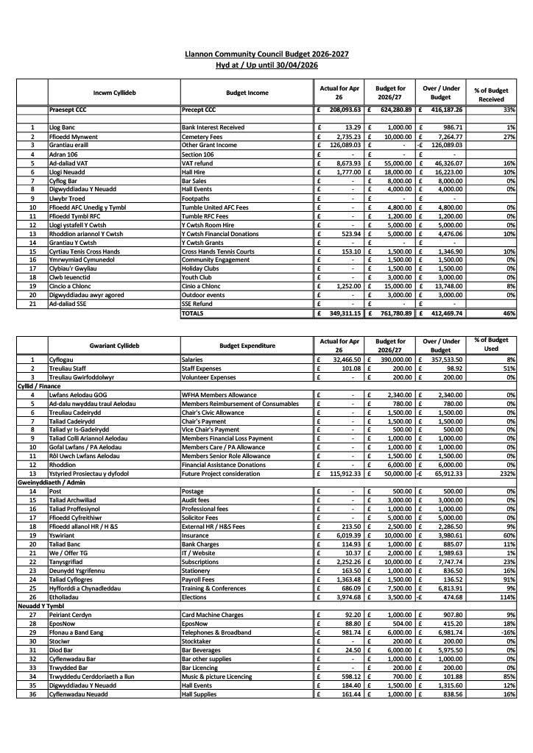
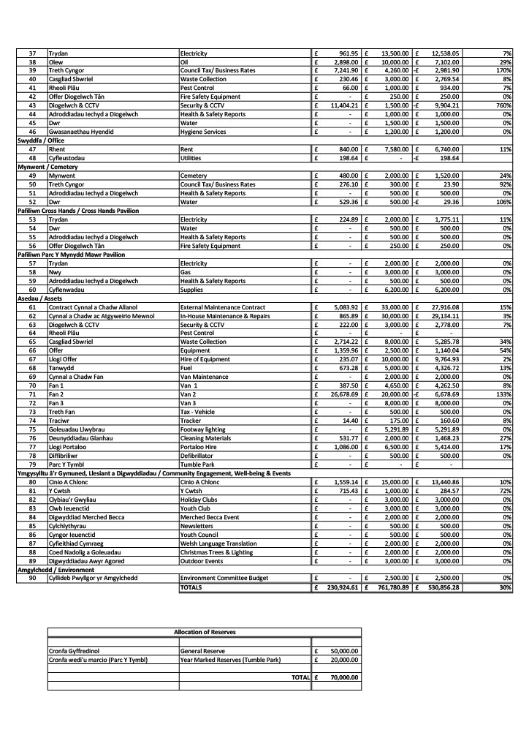
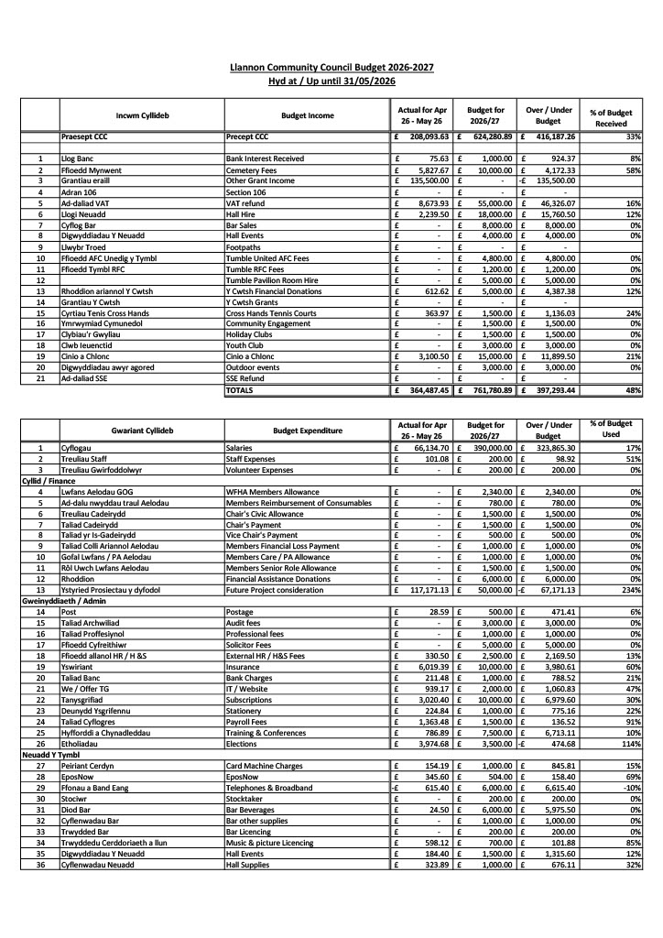
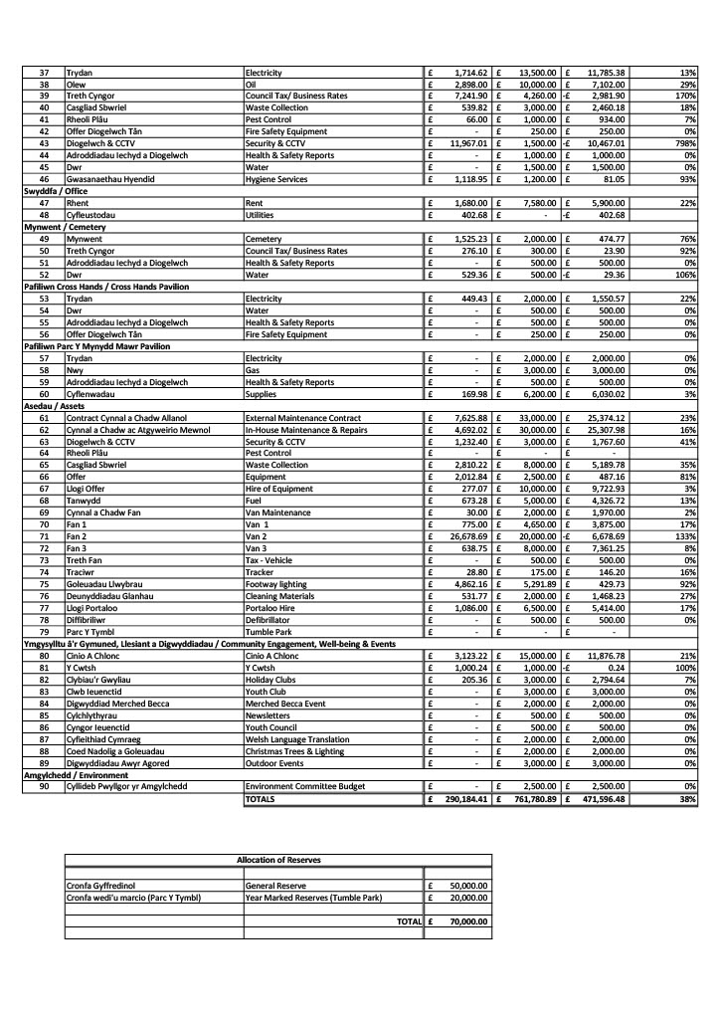

Cofnodion Pwyllgor Cyllid Cyngor Cymuned Llannon
Dydd Llun 13 Gorffennaf 2026 am 5.00yp Drwy Teams

Dechreuodd y cyfarfod am 5.00yp

Cofnod Rhif 1 – Penodi Cadeirydd Pwyllgor Cyllid 2026–2027.

Cynigiodd RD ethol Y Cynghorydd J. Owen yn Gadeirydd ar gyfer 2026–2027. Eiliwyd gan JB. Derbyniwyd yn unfrydol.

Penderfynwyd mai Y Cynghorydd J. Owen yw Cadeirydd y Pwyllgor Cyllid ar gyfer 2026–2027.

Cofnod Rhif 2 – Aelodau’n bresennol.

Cllr. R. Lloyd Davies (RD)
Cllr. J. Owen (JO)
Cllr. J. Burree (JB)

Hefyd yn bresennol:

Miss Ff. Davies – Dirprwy Brif Swyddog & RFO (FD)

Cofnod Rhif 3 – Ymddiheuriadau ac esboniadau am absenoldeb.

Cllr. J. Anderson (JA) – Cyfrifoldebau Gwaith

Cofnod Rhif 4 – Datganiadau o Fuddiant.

Dim datganiadau newydd o fuddiant.

Cofnod Rhif 5 – Adolygu Llyfrau Arian y Cyngor ar gyfer Mawrth 2026.

Cylchredwyd y llyfrau canlynol ymlaen llaw:

• Llyfr Arian Cyfrif y Cyngor – Mawrth 2026
• Llyfr Arian Cyfrif y Neuadd – Mawrth 2026
• Llyfr Arian y Rhagdreuliau – Mawrth 2026
• Llyfr Arian y Cronfeydd Wrth Gefn – Mawrth 2026
• Llyfr Arian Soldo – Mawrth 2026
• Llyfr Arian Y Cwtsh – Mawrth 2026
• Llyfr Arian Cinio a Chlonc – Mawrth 2026

Trafodwyd pob un gan yr aelodau.

Cynigiodd JB gadarnhau’r llyfrau; eiliwyd gan RD; derbyniwyd yn unfrydol.

Penderfynwyd cadarnhau pob un o’r llyfrau uchod ar gyfer Mawrth 2026.

Cofnod Rhif 6 – Adolygu Llyfrau Arian y Cyngor ar gyfer Ebrill 2026.

Cylchredwyd y llyfrau canlynol ymlaen llaw:

• Llyfr Arian Cyfrif y Cyngor – Ebrill 2026
• Llyfr Arian Cyfrif y Neuadd – Ebrill 2026
• Llyfr Arian y Rhagdreuliau – Ebrill 2026
• Llyfr Arian y Cronfeydd Wrth Gefn – Ebrill 2026
• Llyfr Arian Soldo – Ebrill 2026
• Llyfr Arian Y Cwtsh – Ebrill 2026
• Llyfr Arian Cinio a Chlonc – Ebrill 2026

Trafodwyd pob un gan yr aelodau.

Cynigiodd RD gadarnhau’r llyfrau; eiliwyd gan JB; derbyniwyd yn unfrydol.

Penderfynwyd cadarnhau pob un o’r llyfrau uchod ar gyfer Ebrill 2026.

Cofnod Rhif 7 – Adolygu Llyfrau Arian y Cyngor ar gyfer Mai 2026.

Cylchredwyd y llyfrau canlynol ymlaen llaw:

• Llyfr Arian Cyfrif y Cyngor – Mai 2026
• Llyfr Arian Cyfrif y Neuadd – Mai 2026
• Llyfr Arian y Rhagdreuliau – Mai 2026
• Llyfr Arian y Cronfeydd Wrth Gefn – Mai 2026
• Llyfr Arian Soldo – Mai 2026
• Llyfr Arian Y Cwtsh – Mai 2026
• Llyfr Arian Cinio a Chlonc – Mai 2026

Trafodwyd pob un gan yr aelodau.

Cynigiodd JB gadarnhau’r llyfrau; eiliwyd gan RD; derbyniwyd yn unfrydol.

Penderfynwyd cadarnhau pob un o’r llyfrau uchod ar gyfer Mai 2026.

Cofnod Rhif 8 – Derbyn Cymod Banciau Mawrth 2026, Ebrill 2026, Mai 2026.

Cylchredwyd ymlaen llaw.

Cynigiodd RD ei dderbyn; eiliwyd gan JB; derbyniwyd yn unfrydol.

Penderfynwyd bod Cymod Banciau Mawrth 2026. Ebrill 2026 a Mai 2026 wedi’i dderbyn a’i wirio.

Cofnod Rhif 9 – Derbyn Taflen Monitro Cyllideb hyd at 31/03/2026, 30/04/2026 a 31/05/2026.

Cylchredwyd ymlaen llaw.

Cynigiodd RD ei dderbyn; eiliwyd gan JB; derbyniwyd yn unfrydol.

Penderfynwyd bod y ddogfennau wedi’i derbyn a’i gwirio.

Cofnod Rhif 10 – Dyddiad y cyfarfod nesaf.

Cytunwyd i gynnal y cyfarfod nesaf ar Dydd Llun 10fed o Awst 2026.

Daeth y cyfarfod i ben am 5.27yp

